**Composing Complete Sentences  
with Conjunctions**

|  |  |  |
| --- | --- | --- |
| **Compound Sentences:** Use these models to help you **avoid run-on sentences and comma splices**. | | |
| **1.** Independent clause, comma  *She liked to eat popcorn,* | coordinating conjunction  *but* | + independent clause.  *it got stuck in her teeth.* |
| **2.** Independent clause; semi-colon  *She liked to eat popcorn;* | conjunctive adverb, comma  *furthermore,* | + independent clause.  *she liked watching movies.* |
| **Complex Sentences:** Use these models to help you **avoid sentence fragments**. | | |
| **3.** Independent clause +  *She watched the documentary* | subordinating conjunction  *because* | + dependent clause.  *he had recommended it.* |
| **4.** Subordinating conjunction +  *When* | dependent clause, comma  *she finished watching,* | + independent clause.  *she called him.* |
| **Simple Sentences** | | |
| **5.** Conjunctive adverb, comma +  *However,* | independent clause.  *he was busy with homework.* |  |
| **6.** Coordinating conjunction, comma +  *And,* | independent clause.  *she had homework of her own.* | (Grammatically correct; not preferred.) |
| **7.** Independent clause.  *She went to bed late that night.* |  |  |

* 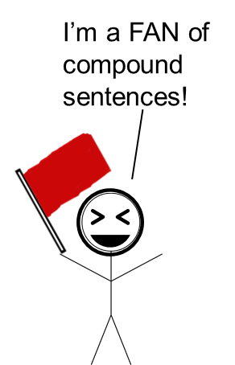**Coordinating Conjunctions** can be remembered using the mnemonic device “FANBOYS”:

|  |  |
| --- | --- |
| **F** | For |
| **A** | And |
| **N** | Nor |
| **B** | But |
| **O** | Or |
| **Y** | Yet |
| **S** | So |

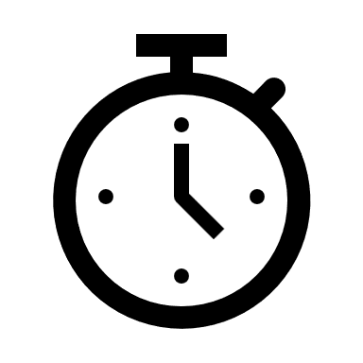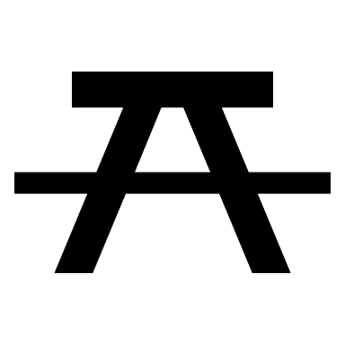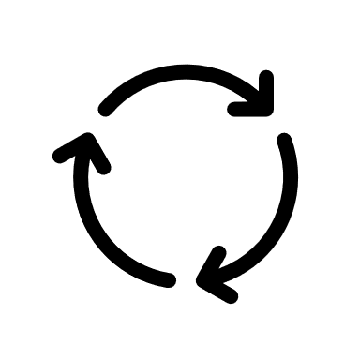

* **Subordinating Conjunctions** often relate to time, place, or cause-and-effect.

**I saw a wabub!!**

Use this mnemonic device to help remember some of the most common subordinating conjunctions:

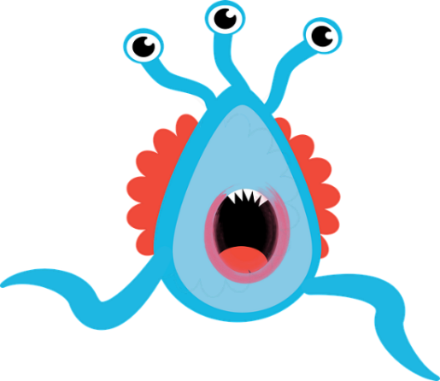

Acaladolopes. (2019). *Monster scared running scary* [Graphic]. Retrieved from [http://pixabay.com/  
vectors/monster-scared-running-scary-4037255](http://pixabay.com/vectors/monster-scared-running-scary-4037255)

|  |  |
| --- | --- |
| **I** | If |
| **s** | Since |
| **a** | As |
| **w** | When |
| **a** | Although |
| **w** | While |
| **a** | After |
| **b** | Before |
| **u** | Until |
| **b** | Because |

|  |  |  |  |  |
| --- | --- | --- | --- | --- |
| Function | **Coordinating Conjunctions** | **Correlating Conjunctions** | **Subordinating Conjunctions** | **Conjunctive Adverbs** (Transitions) |
| **Addition** | and | Both…and…  Not only…,but also |  | Also,  Additionally,  In addition,  Moreover,  Further,  Furthermore,  Besides,  On top of that, |
| **Alternative** | or  nor | Either…or…  Neither…nor… |  | Otherwise, |
| **Cause-Effect Relationship** | for  so |  | Because…,  Since…,  As…,  In order to…, | For this reason,  Because of…,  Therefore,  Thus,  Hence,  As a result,  As a result of…,  Consequently,  Accordingly,  Owing to…,  Due to…, |
| Function | **Coordinating Conjunctions** | **Correlating Conjunctions** | **Subordinating Conjunctions** | **Conjunctive Adverbs** (Transitions) |
| **Contrast, Concession, & Difference** | but  yet |  | Though…,  Although…,  Even though…,  Except for the fact that…,  Despite the fact that…,  Whereas…,  While…, | However,  In contrast,  On the contrary,  On the other hand,  Except for…,  Instead,  Alternatively,  Conversely,  However,  Nevertheless,  Nonetheless,  Despite this,  In spite of this,  Apart from…,  Instead of…,  In contrast to…,  Unlike…,  In spite of this,  Despite…, |
| **Conditional** | but |  | If…,  Even if…,  Only if…,  If only…,  Unless…,  As long as…,  So long as…,  Assuming…,  On the condition that…,  Provided that…, | Having said that,  Still,  In that case,  That being so,  Otherwise, |
| **Comparison & Similarity** |  |  | Just as…, | In the same way,  Likewise,  Similarly,  Comparably,  Like…,  As with…, |
| **Emphasis** |  |  |  | First and foremost,  Clearly,  Ultimately,  Above all,  Notably,  Indeed,  Significantly, |
| **Examples** |  | From…to… |  | For example,  To illustrate,  For instance, |
| Function | **Coordinating Conjunctions** | **Correlating Conjunctions** | **Subordinating Conjunctions** | **Conjunctive Adverbs** (Transitions) |
| **Examples** (continued) |  |  |  | That is,  Specifically,  In particular,  In the case of…,  As revealed by…, |
| **Opinion** |  |  |  | Fortunately,  Luckily,  Sadly,  Unfortunately, |
| **Restatement & Summary** |  |  |  | Again,  To sum up,  All in all,  In brief,  In other words,  In sum,  That is,  In summary,  Clearly,  Ultimately,  In conclusion,  To summarize,  Generally,  In general, |
| **Sequence** | and |  |  | First and foremost,  To begin,  First(ly),  Second(ly),  Third(ly),  Next,  Then,  Finally, |
| **Time** | yet |  | After…,  Before…,  As soon as…,  When…,  While…,  As…, | After,  Afterwards,  Beforehand,  Previously,  Up till now,  At present,  Presently,  Currently,  Immediately,  Subsequently,  Meanwhile,  Eventually,  In the past,  Prior to…, |