Chemistry 350

Organic Chemistry I

________________________________________________________________________

Report Book 2019-2021



Course team

CHEM350 Report Book Authors: Dietmar Kennepohl, Lawton Shaw,
Robert D. Carmichael, and
Lois M. Browne

CHEM350 Report Book Illustrations: Aimee Caouette

Science Laboratory Manager: Rafael Hakobyan

CHEM350 Course Professor: Dr. Dietmar Kennepohl

Every effort has been taken to ensure that these materials comply with the requirements of copyright clearances and appropriate credits. Athabasca University will attempt to incorporate in future printings any corrections which are communicated to it.

The inclusion of any material in this publication is strictly in accord with the consents obtained and Athabasca University does not authorize or license any further reproduction or use without the consent of the copyright holder.

Athabasca University 2000, 2004, 2006, 2009, 2010, 2012, 2016, 2019
All rights reserved
Printed in Canada

CHEM 350 Report Book Contents

_______________________________________________________________________________

General Introduction 1

Report Book Structure 3
Acknowledgements 4

Experiment 1 Melting-point determinations 5
Pre-lab Questions 5
Experiment 1 Lab Report 7-10

Experiment 2 Recrystallization 11
Pre-lab Questions 11
Experiment 2 Lab Report 13-17

Experiment 3 Distillation-simple and fractional 19
Pre-lab Questions 19
Experiment 3 Lab Report 21-25

Experiment 4 Refractive index 27
Pre-lab Questions 27
Experiment 4 Lab Report 28-32

Experiment 5 Extraction, separation, drying agents 33
Pre-lab Questions 33
Experiment 5 Lab Report 35-41

Experiment 6 The reactions of common functional 43
groups and infrared spectroscopy tutorial
Part 1: Hydrocarbons
Pre-lab Questions 43
Experiment 6 Lab Report 44-54

CHEM 350 Report Book Contents (cont.)

_______________________________________________________________________________

Experiment 7 Extraction of usnic acid 55
Pre-lab Questions 55
Experiment 7 Lab Report 56-61

Experiment 8 Prep. of cyclohexene from cyclohexanol 63
Pre-lab Questions 63
Experiment 8 Lab Report 65-71

Experiment 8 (Alternate) Prep. of methylpentenes 73
Pre-lab Questions 73
Experiment 8 Alternate Lab Report 75-84

Experiment 9 The nitration of acetanilide 85
Pre-lab Questions 85
Experiment 9 Lab Report 87-94

Table of Reagents 95

Prelab Question help 99
Appendix of Unknown Infrared Spectra
CHEM350 Preparedness Performance Product (PPP) Eval. Form

Welcome to Organic Chemistry 350’s Laboratory Report Workbook

This report book, along with the 'Chemistry 350 Lab Manual', will help you prepare for a single weekend (~20h, 2.5 days), or 3-4 days straight (~24-32h) of supervised lab instruction. All preparatory work in this report book (~12 h to finish, see list on page 3), may be completed and submitted to the Chemistry Lab Co-ordinator / Instructor prior to attending the labs, or just before the start of the Friday evening lab session.

In order to successfully complete the laboratory component, please be aware of the following 4 step process of instruction. It is the intention of this CHEM350 Report book to provide you with the means of completing all four steps.

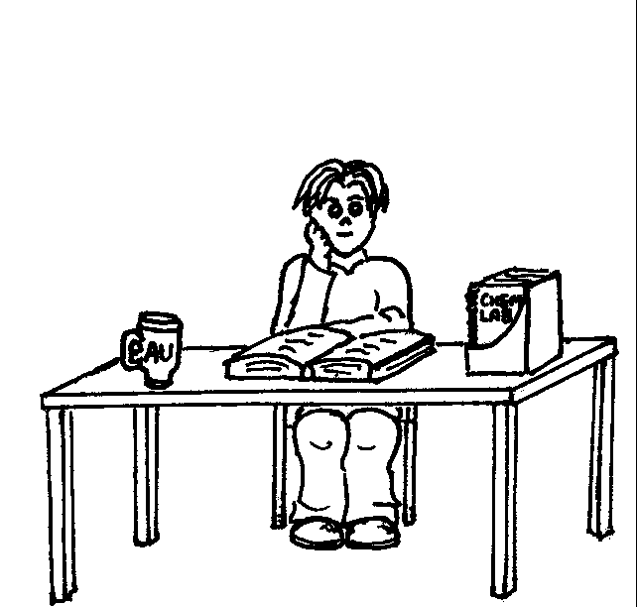
Step 1: First we tell you what you are going to do.

Find out by reading the lab manual, doing the pre-lab questions in this report book, and filling out the Table of Reagents etc., i.e., preparing for the labs at home. (By doing so you are able to work more efficiently in the lab and the over-all time spent in the supervised lab can be reduced to ~20 hours from the usually 32 hours.)

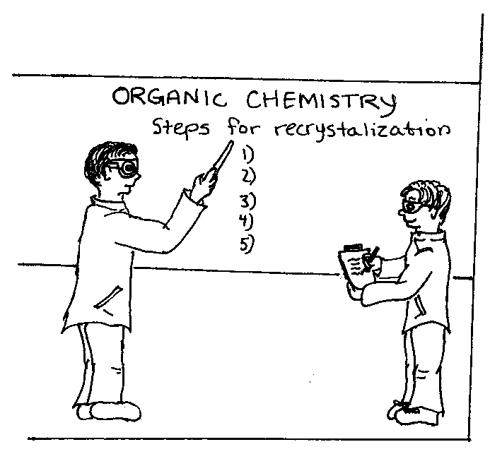
Step 2: Next we show you how to do it.

When you come to the lab, a lab instructor will
give a safety orientation, followed by a series
of mini lab lectures on each experiment.
Various techniques will be demonstrated and
you will be shown how to handle chemicals,
dispose of hazardous waste, and operate the
equipment.

Step 3: Lab Time: Now you do what you've read, been told, and shown.

This is the time you spend in the lab performing your experiments, making your products, and recording your results in this report workbook.


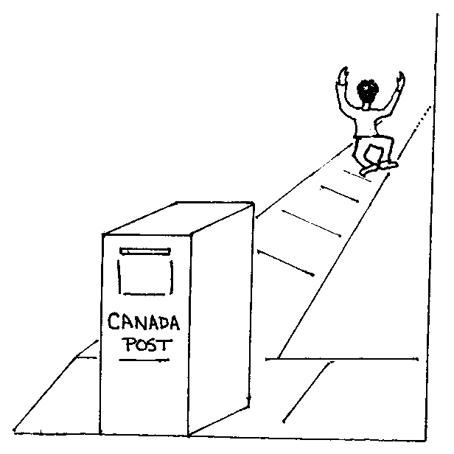
Step 4: Finally, you tell us what you did.

This is the report writing stage. Actually most of your reports will have been written while in the lab. At home you will only have to do your calculations, write your discussion and conclusion and answer the questions at the end of each experiment.

Report Book Structure and How to Prepare for the Labs:

This CHEM350 Report Book is to be used in conjunction with the CHEM350 Organic Chemistry I Lab Manual. It consists of an Introduction, Experiment Report Forms, Table of Reagents and a Course Evaluation. The reports are to be completed one month after of the lab session you attended. As a safety precaution, it is advisable to photocopy your reports before mailing them to your tutor for marking. Note: the marked reports are not returned to you.

How to best do the Report Book Exercises

1. First read through the lab manual introduction, and then answer the pre-lab questions for each experiment.
2. Complete the Objectives in the Experiment Report and begin to draft of your introduction.
3. Complete the Procedure (Refer to lab manual pages) and make a flowchart if necessary.
4. Complete the Table of Reagents for each experiment (detach a copy of the TOR to avoid flipping back and forth)
5. You are now ready to come to the lab and do the experimental work.

Note: Each experiment in the report book has the following headings:
Report Book Heading | Purpose and Use
1. Experiment Prelab Questions | Answer these questions to help you prepare and understand what you are doing in the lab. In order to answer these questions you will have to consult the CHEM350 Lab Manual, and to read the 'Introduction to Concept', and 'Background Information' sections of this manual.  You may optionally submit these questions to the lab coordinator for review just before attending the lab.*
2. Objectives | Lists what you should learn from the lab. (see also lab manual). Use this information to fill in 'Objectives' in your Lab Write-up. When appropriate, write out any chemical reactions.
3. Introduction | Briefly state how the objectives of the experiment will be achieved and provide the relevant background information.
4. Procedure | Refer to the lab manual and only note any modifications or changes. Fill out the Table of Reagents**. Optionally you may use the flowchart or procedural step table to record your work and observations. No need to do both ways.
The sections of your report shown below are completed while doing the experiment, or at home after the lab session.
5. Results | While doing or immediately after your experiment, record your results in this section of the report.
6. Discussion an Conclusion | As soon after the lab as possible, discuss your results in light of the objectives, and make the appropriate conclusions. Remember to discuss sources of potential error and loss.
7. Post Lab Questions | Answer these questions to prove you understand what you did in the lab. To be completed after the experiment is finished. Submit your answers by mail along with your report and the Course Evaluation.
*CHEM350 Prelab questions are also available online at: http://science.pc.athabascau.ca/chem350.nsf
**CHEM350 Reagents are also available online at: http://science.pc.athabascau.ca/chem350.nsf
Acknowlegements:

The authors wish to thank Ms. Aimee Caouette for all the artwork. Athabasca University also wishes to thank Drs. K. Tanabe and T. Tamura and for all the IR Spectra used in this manual (pp. 65, 76, and 84). They were obtained from the SDBS web site: http://www.aist.go.jp/RIODB/SDBS/ (29-Sep-1999).

The following sources are also hereby acknowledged:

Laboratory Manual, Chemistry 320, Athabasca University, 1984.
Laboratory Manual, Chemistry 320, University of British Columbia, 1972-73.
Laboratory Manual, Chemistry 240, Dalhousie University, 1973.
Laboratory Manual, Chemistry 240A/B, Sir Wilfred Grenfell College, 1982-83.
Laboratory Manual, Chemistry 240, Memorial University of Newfoundland, 1976-77.

L.M. Browne, 1998. Laboratory Manual, Chemistry 161, University of Alberta.
L.M. Browne, 1998. Laboratory Manual, Chemistry 163, University of Alberta.
L.M. Browne, 1993. Laboratory Manual, Chemistry 361, University of Alberta.

Lehman, J.W. 1999. Operation Organic Chemistry: A Problem-Solving Approach to the Laboratory Course, 3rd ed., Prentice Hall, New Jersey.

Mayo, D.W., R.M. Pike, and S.S. Butcher. 1989. Microscale Organic Laboratory, 2nd ed., John Wiley and Sons, Toronto, pp.229-232.

McMurry, J., 1992. Organic Chemistry, 3rd ed., Brooks/Cole Publishing Company, Pacific Grove, CA.

Weast, R.C. et al, 1974. CRC Handbook of Chemistry and Physics, 65th ed., CRC Press, Inc., Boca Raton, FL.

Each experiment has been modified and rewritten, keeping the particular needs of Athabasca University students in mind. The procedures described in this manual have been checked in our Athabasca laboratories by Jerry Pyrozko, Roger Klemm, Glen Conlin, and Robert Carmichael. Special thanks to Ms. Aimee Caouette for her help on the IR Tutorial (Summer 1999). The comments and suggestions received from the individuals mentioned above were greatly appreciated by the Course Co-ordinator.

Chem350 Experiment 1 Report Date:___________

Student Name:___________________ ID Number:___________

Experiment 1 Prelab Questions:

1. Why do we need to know the melting point of a substance?
a. To determine the exact time it takes for a sample to melt, and what color the compound becomes after heating.
b. To determine the purity of a sample, 1-2 ºC range = pure, 3 C range or more = impure.
c. To identify and then determine the crystal lattice structure of a compound.
d. To identify the compound before using it in a reaction.

2. List the three steps used to prepare a melting point sample?
a. (1) Mix the solid well before sampling. (2) Transfer the compound to a melting point tube. (3) Pack the sample to a height ~1 mm.
b. (1) Transfer a small amount of compound to a melting point tube. (2) Pack the sample to a height ~5 mm. (3) Place the packed sample into the melting point apparatus and begin heating.
c. (1) Crush the solid using a mortar and pestle. (2) Transfer a small amount of powder to a melting point tube. (3) Pack the sample to a height ~1 mm.
d. (1) Crush the solid in a mortar. (2) Transfer a large amount of powder to a melting point tube. (3) Only pack the sample if the melting point tube is too full.

3. What are three main concerns regarding mercury filled melting point thermometers?
a. Accuracy, precision, and fragility.
b. Room temperature readings, accuracy, and spilt mercury disposal.
c. Use for only mp determinations, they must be calibrated, and never heat above 250 C.
d. Emergent stem error, paralax, and difficulty in finding a cheap supplier.

4. Define the temperatures recorded at the beginning and end of the melting point range.
a. the melting points happen slow and are very hard to see.
b. lower limit = when the first drop of liquid is seen; upper limit = when the sample is completely liquid.
c. lower limit = when the sample is completely liquid; upper limit = when the sample has evaporated from the melting point tube.
d. lower limit = when the sample begins to shrink/shrivel; upper limit = when the sample is completely liquid.

5. The CRC Handbook of Chemistry and Physics sometimes reports the melting point of a compound as a single number. What does this mean?
a. It's the midpoint value between the upper and lower limit of the melting point range.
b. It's the lower limit of the melting point range.
c. It's the upper limit of the melting point range.
d. It's the upper limit for the melting point range, corrected for barometric pressure effects.

6. The melting point apparatus should be heating at what rate (? C/min) as it approaches the melting point of the compound?
a. The maximum rate of heating. Use the boost switch.
b. 3
c. 2
d. 1

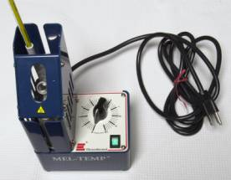
7. What is the name of the piece of laboratory equipment on the right?
a. melting point apparatus
b. pan balance
c. spectrophotometer
d. pH meter

8. The identification of a unknown solid will be achieved by mixed melting point determination.
a. True
b. False

Experiment 1 - Lab Safety

9. 'WHMIS' stand for?
a. Workplace Hazardous Materials Information and Symbols
b. Worker Hazardous Materials Information System
c. Workplace Hazardous Materials Information System
d. Worker Hazardous Materials Information Sheets

10. 'MSDS' stand for?
a. Most Severe Data Sheet
b. Material Sheet for Dangerous Supplies
c. Material Safety Danger Sheet
d. Material Safety Data Sheet
Chem350 Experiment 1 Report Date:___________

Student Name:___________________ ID Number:___________

Title:

Objective(s):

Introduction: (definition and importance of mp, how one assesses purity using mp, mixed mp for ID, etc.)

Procedure: Ref. format: (author /surname, initials/, date. Title, publisher, page numbers)

Part A: Single melting point determination of unknown sample
Procedural Step | Observations
- Record unknown code number

- Record approximate melting point of the unknown

- Prepare melting point tube
- Crush the sample using a mortar and pestle before loading the melting-point tube

4. Place tube in mp apparatus and heat sample

5. Record your experimentally determined melting point.

Procedure (cont.):

Part B: Mixed melting point determination of an unknown sample
Procedural Step | Observations
1. Record unknown code number and suggested candidates

- Literature Values of Unknown candidates

- Prepare melting point tubes

- Crush the sample using a mortar and pestle before loading the melting-point tube

5. Record your experimentally determined melting point.

Table of Reagents for Exp. 1
Reagent | Formula | Mwt.  (g/mol) | mp  (°C) | bp  (°C) | Hazardous Properties
benzoic acid | C₆H₅COOH |  |  |  | Irritant
3-chlorobenzoic acid | ClC₆H₄COOH |  |  |  | Irritant
biphenyl | C₆H₅C₆H₅ |  |  |  | Irritant
salicylic acid | HOC₆H₄COOH |  |  |  | Toxic, Irritant
trans-cinnamic acid |  |  |  |  | Irritant
2-methylbenzoic acid | CH₃C₆H₅COOH |  |  |  | Irritant
4-nitrobenzaldehyde |  |  |  |  | Irritant
urea | NH₂CONH₂ | 60.06 | 133-135 |  | Irritant
acetone (wash) | CH₃COCH₃ |  |  | 56.5 | Flammable, Irritant

Results:
Part A
Melting point of sample # ____________ = ______________________

Part B
Possible identity of unknown compound # ______:

1. __________________________ ; mp (Reference: )

2. __________________________ ; mp (Reference: )

Melting point of unknown compound # ____________ = _____________

Melting point obtained when unknown compound # ________ is mixed with

- _______________________________________ = _______________ (report range)

- _______________________________________ = _______________ (report range)

Conclusion:
(concluding statement, objectives achieved?)
Structure of Unk.#_____
The above results indicate that unknown compound #

__________ is probably ___________________.
(The structure of unknown ________ is drawn in the box.)

Experiment 1 Post Lab Questions:

Answers to these post lab questions must be submitted with your laboratory report.

- In the lab manual introduction to this experiment, you were warned that heating the sample too quickly in the region of the melting point would result in the experimentally determined melting point being higher than the true value. Explain why this is so.

- What is an eutectic mixture? How would you decide whether a given sample was a pure compound or an eutectic mixture of two compounds?

- You are working in the lab, and you find an unlabelled vial with a white crystalline solid inside. In order to determine the identity of the compound, what would you have to do?

- i) Give two reasons why you should calibrate your thermometer before using it of a melting point determination.

ii) How do you properly ‘cool off’ a melting point thermometer?

Chem350 Experiment 2 Report Date:___________

Student Name:___________________ ID Number:___________

Experiment 2 Prelab Questions:

1. Why does a chemist recrystallize an organic compound?
a. To determine the solubility of the compound in a particular solvent.
b. To convert the compound into a eutectic mixture.
c. To identify the compound.
d. To purify a compound prior to analysis or use in a reaction.

2. Which statement briefly explains how recrystallization increases the purity of a compound?

a. Recrystallization is an art and it is by luck you get any pure crystals at all.
b. Assuming that impurities are highly soluble in the selected solvent at all temperatures, by dissolving the desired impure compound in a minimum of hot solvent, and then cooling the solution, brand new crystals form while the impurities stay in solution, resulting in purer than original crystals.
c. By dissolving the compound in hot solvent and then cooling the solution, brand new crystals form which are purer than the original crystals.
d. Assuming that impurities are only highly soluble in the hot solvent, by dissolving the desired impure compound in a minimum of hot solvent, and then cooling the solution, brand new crystals form while the impurities stay in solution, resulting in purer than original crystals.

3. The following are the 5 steps of the recrystallization procedure:
i. Select the recrystallation solvent.
ii. Dissolve the crude solid in a minimum amount of hot solvent (= saturated solution).
iii. Make a decision to hot gravity filter or not.
iv. Slow cool and allow the crystals to form.
v. Collect the crystals using vacuum filtration and wash with ice cold recrystallization solvent, and then allow the crystals to dry to a constant weight.
a. True
b. False

4. What are the criteria for selecting a solvent suitable for a single solvent recrystallization?
a. soluble in hot solvent and soluble in cold solvent.
b. insoluble in hot solvent and insoluble in cold solvent.
c. insoluble in hot solvent and soluble in cold solvent.
d. soluble in hot solvent and insoluble in cold solvent.

5. Boiling stones must be added to the recrystallization solvent prior to heating. Why (Note: there are two very good reasons for doing so)?
a. In order to prevent the solution from 'bumping' in the first place.
b. To avoid a sudden violent eruption of liquid should the solution be hot when the stones are added.
c. a and b are correct.
d. none of the above.

6. What are two situations where you are required to perform a hot gravity filtration.
a. colored impurities are present (therefore charcoal was added), and to remove soluble impurities.
b. soluble impurities are present (therefore charcoal was added), and to remove insoluble impurities.
c. colored impurities are present (therefore charcoal was added), and to remove insoluble impurities.
d. to remove boiling stones that were added, and to remove soluble impurities.

7. Which piece of equipment is not normally used to perform a recrystallization:
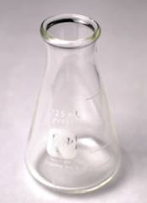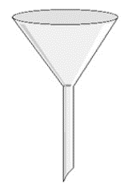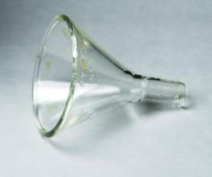
a. Erlenmeyer flask
b. Long narrow stemmed glass funnel
c. Short stemmed wide mouthed glass funnel
d. Pasteur pipette

8. If too much solvent is used when making a saturated solution, the yield of crystals at the end of the recrystallization will be reduced.
a. True
b. False

Experiment 2 - Lab Safety
9. Which of the four following statements is false?
a. Never heat a flammable solvent directly on a hot plate.
b. Never heat an Erlenmeyer flask filled more than 2/3rds full of liquid.
c. Always remember to use boiling stones when heating a solvent.
d. Acetanilide waste can be washed down the sink drain.

10. If you are unable to find any hazardous properties for a compound in the literature, you should
a. leave the Hazardous Properties column blank in the Table of Reagents in your CHEM350 Report Book.
b. assume the organic compound is safe; it has no hazardous properties.
c. assume that the organic compound is at least a 'suspected irritant'.
d. none of the above. Ask your lab instructor before using.

11. Acetanilide waste should be placed into the
a. General Organic Waste bottle in the fumehood.
b. Halogenated Organic Waste bottle in the fumehood.
c. Flushed down the drain with water.
Chem350 Experiment 2 Report Date:___________

Student Name:___________________ ID Number:___________

Title:

Objective(s):

Introduction:

Procedure:
(Ref: )

Single Solvent recrystallization of impure acetanilide

Procedural Step | Observations
- Record appearance and amount of impure acetanilide weighed.

Single Solvent Recrystallization Procedure
(record appearance of solvent throughout and
note any volume changes. Record elapsed time)

1. Select the solvent.

2 Heat volume of solvent to its bp.

3.

4.

5.

Final Analyses

Table 1. Table of Reagents for Exp. 2
Reagent | Formula | Mwt.  (g/mol) | mp  (°C) | bp  (°C) | Hazardous Properties
acetanilide |  |  |  | NA
sucrose | C₁₂H₂₂O₁₁ |  |  | NA
calcium carbonate | CaCO₃ |  |  | NA
silica | SiO₂ |  |  | NA
charcoal |  |  |  | NA
water | H₂O |  | 0 | 100 | Burns when hot
acetone (wash) | CH₃COCH₃ |  |  | 56.5 | Flammable liquid, irritant
NA= not applicable.

Experiment 2 Results:

Table 2. Table of Observations*:

Procedural Step | Comment or Observation
Recrystallization solvent used:

Volume of recrystallization solvent used:

Appearance of solution after addition of charcoal

Time allowed for crystals to form:

*This table may be repetitious, but really it is a place for you to bring forward some very important observations from your flowchart or procedure./observ. page that are very relevant to your results and calculations.

Table 3. Table of Product Recrystallization Results

 | Mass of Impure Acetanilide (g) | Mass of Pure Acetanilide Recovered (g) | Appearance of Crystals | % Recovery Yield | Melting Point  (°C)
Impure acetanilide
'Pure' acetanilide
2nd crop 'Pure' acetanilide

% recovery yield calculation:

Discussion:
Comments on and reasons for yield (high or low), and sources of error:

Structure of Product
Conclusion:

Experiment 2 Post Lab Questions:

Answers to these post lab questions should be submitted with your report.

- The table below shows the solubility of a certain organic compound in water at five different temperatures.

Temperature (ºC) Solubility of compound (in 100 mL of water)
0 1.5 g
20 3.0 g
40 6.5 g
60 11.0 g
80 17.0 g

- Plot a graph of the solubility of the compound versus temperature. Draw a smooth curve through the data points.
- If a student attempts to recrystallize a 0.5 g sample of this compound by heating it to 80º C with 5.0 mL of water, would all of the sample dissolve? Briefly justify your answer.

- Assuming that the answer to part b is ‘Yes’, at what temperature will the crystals begin to appear when the student’s solution begins to cool?

- If the student cooled the solution to 0º C and filtered off the crystals, what is the maximum possible percentage recovery? What mass of the sample will remain in the filtrate?

- Explain why you should slowly cool the filtered saturated solution obtained in step 3 of the recrystallization procedure?

- During the last step of the recrystallization procedure, you collect the crystals by vacuum filtration. Why do you use ice cold recrystallization solvent to help transfer all the crystals to the Büchner funnel and wash the crystals?

- Briefly explain the circumstances under which a mixed solvent recrystallization method would be used to recrystallize a given compound.

Graph paper insert

[This is a blank page]

Chem350 Experiment 3 Report Date:___________

Student Name:___________________ ID Number:___________

Experiment 3 Prelab Questions:

1. Why does a chemist distil an organic liquid?
a. To determine the polarity of a particular solvent.
b. To purify a compound prior to analysis or use in a reaction.
c. To identify the compound.
d. To convert the compound into its vapour form.

2. Which statement best explains how distillation purifies a compound?
a. Distillation is used to concentrate a desired compound by removing undesired impurity vapours.
b. Assuming that the impurity has a higher boiling point (must be greater than 25-30 ºC different than the solvent), the desired solvent can be separated by heating it to its vapour phase and then collecting the pure vapours in a receiver flask.
c. Distillation involves heating a liquid to its boiling point, at atmospheric or reduced pressure, to convert it to its vapour, and then condensing the vapour back into a liquid by cooling with a condenser and collecting the condensate in a receiving flask.
d. Distillation involves heating a liquid to its boiling point to convert it to its vapour, and then converting the vapour back to liquid by icing the receiver flask.

3. The various heat sources available for a distillation, and when it is appropriate to use each heat source are:
i. Bunsen burner (used only for aqueous non-flammable high boiling point (bp) solvents).
ii. heating mantle (can be used for flammable solvents with bp up to 150 ºC).
iii. steam bath (can be used for flammable solvents up to 85 ^{ο}C)
iv. hot plate plus flat bottom dish/water bath (for low bp flammable solvents)
a. True
b. False

4. Boiling stones must be added to the distillation flask prior to heating. Why?
a. In order to prevent the solution from 'bumping'.
b. To avoid a sudden violent eruption of liquid should the solution already be hot when the stones are added.
c. To promote smooth boiling of the solvent.
d. all of the above.

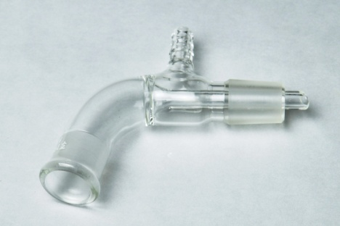
5. Which is the name of the piece of glassware on the right?
a. Claisen adaptor
b. three way connector or still head
c. vacuum take-off adaptor
d. thermometer adaptor

6. Simple distillations can be performed on a mixture of two solvents only if the boiling points are different by more than 15-20 ºC. Fractional distillations are performed on a mixture of two solvents if the boiling points are different by less than 25-30 ºC.
a. True
b. False

Experiment 3 Lab Safety

7. Which of the four following statements is false?
a. Never heat a distillation flask to dryness.
b. Never heat a round bottom flask filled more than 1/2 full of liquid.
c. Always remember to use boiling stones when heating a solvent.
d. Ensure you have a open system before you begin heating.
e. Once your distillation apparatus is fully assembled, then insert your thermometer down through the thermometer adapter.

8. When setting up the condensor, adjust the cooling water flow so that:
a. it flows in the bottom and out the top of the condensor, at a maximum flow rate.
b. it flows in the top and out the bottom of the condensor, at a maximum flow rate.
c. it flows in the bottom and out the top of the condensor, at a minimum flow rate.
Chem350 Experiment 3 Report Date:___________

Student Name:___________________ ID Number:___________

Title:

Objective(s):

Introduction:

Procedure:
(Ref: )
Changes/Modification:

Part A: Distillation of impure cyclohexanol

Procedural Step | Observations
- Record amount of impure cyclohexanol used.

Distillation Procedure
1.
2.
3.
4.
5.
6.

Volume of Forerun

Boiling point range of forerun

Barometric Pressure

Boiling point of product

Part B: Fractional distillation of 50:50 mixture of cyclohexane:toluene.

Procedural Step | Observations
- Record appearance and amount of 50:50 cyclohexane:toluene used.

Fractional Distillation Procedure
1.

2.

3.

4.

5.

6.

Table 1. Table of Reagents for Exp. 3
Reagent | Formula | Mwt.  (g/mol) | mp  (°C) | bp  (°C) | Hazardous Properties
cyclohexanol

toluene
cyclohexane
acetone (wash) | CH₃COCH₃ |  |  | 56.5 | Flammable liq., irritant

Sketch for the assembly of a simple distillation apparatus (fill in labels).
Labels to place on sketch: distillation flask condensor
receiving flask water in
heating mantle water out
boiling stones ice bath
thermometer clamps (3)
three-way connector (still head) vacuum adapter
thermometer adapter 'open to air'
Experiment 3 Results:

Table 2. Table of Observations:*
Procedural Step | Comment or Observation
*This table may be repetitious, but really it is a place for you to bring forward some very important observations from your flowchart or procedure./observ. page that are very relevant to your results and calculations.

Table 3. Part A Table of Product Simple Distillation Results
 | Volume  (mL) | Appearance of Liquid | % Recovery Yield | Boiling Range  (°C)/Pressure | Press. Corrected Boiling Range(°C)
Impure Cyclohexanol
Forerun
'Pure' cyclohexanol

Table 4. Part B Table of Product Fractional Distillation Results
 | Volume  (mL) | Appearance of Liquid | % Recovery Yield | Boiling Range  (°C)/Pressure | Press. Corrected Boiling Range(°C)
50:50 cyclohexane:toluene
Forerun
Fraction 1
Fraction 2
Fraction 3

Discussion:
Comments on and reasons for yield (high or low), sources of error (uncalibrated thermometer, atmospheric pressure effects):

Structure of Products
Conclusion:

Experiment 3 Post Lab Questions:

Answers to these post lab questions should be submitted with your report.

- A student who was performing a distillation for the first time failed to position the thermometer correctly. The bulb was set too high. What effect would this have on the observed boiling point of the liquid being distilled?

- Under perfect conditions, the number of theoretical plates required to separate an ideal mixture of two components of boiling points T_{A} and T_{B} is given by the relationship:

Number of theoretical plates needed = 120
T_{A} - T_{B}

On this basis, how many theoretical plates are needed to separate a mixture of cyclohexane and toluene? (Note: In practice, the actual number of theoretical plates required may be as high as double the number predicted by this equation!)

- You suddenly notice you have forgotten to add boiling stones to your round bottomed distillation flask but the distillation is now in progress. What should you do?

- What is the purpose of the condensor during a distillation?

Chem350 Experiment 4 Report Date:___________

Student Name:___________________ ID Number:___________

Experiment 4 Prelab Questions

1. The two common ways to assess the purity of a liquid organic sample are:
a. thin layer chromatography, and determine its refractive index.
b. distil the liquid and determine its density by determining the mass and volume of product.
c. convert the compound into its vapour form and condense it back to a liquid.
d. fractional distillation of the liquid, followed by refractive index analysis.

2. The refractive index of a liquid is fundamentally based on the change of the speed of
a. flowing water.
b. gaseous molecules.
c. light.

3. The refractive index is dependent upon which two key factors?
a. temperature of the sample and the wavelength of the incident light.
b. the operator of the refractometer and the amount of sample used.
c. density of the sample and the wavelength of the incident light.

4. Which of the following sequences describes the correct order of the steps needed to measure a refractive index?
a. Turn on refractometer, apply sample, adjust side hand wheel, adjust thumb wheel for chromatic aberration, readjust side hand wheel, read meter.
b. Turn on refractometer, apply sample, adjust thumb wheel for chromatic aberration, adjust side hand wheel, readjust side hand wheel, read meter.
c. Turn on refractometer, adjust thumb wheel for chromatic aberration, adjust side hand wheel, apply sample, read meter
d. All of the above (the order does not matter).

5. From the formulae provided below, choose the one which describes the correct method to calculate the percentage error in a refractive index measurement.
- $=\frac{|\text{actual value - theoretical value}|}{\text{theoretical value}}\text{ x 100\%}$=
- $=\frac{\text{actual value}}{\text{theoretical value}}\text{ x 100\%}$=
- $=\frac{|\text{theoretical value -actual value }|}{\text{actual value}}\text{ x 100\%}$=

Experiment 4 Lab Safety

6. What is the major safety concern regarding this experiment?
a) Handling of flammable and toxic solvents.
b) the sodium lamp in the refractometer.
c) keeping the refractometer from moving.
d) the temperature of the sample during refractometer readings.
Chem350 Experiment 4 Report Date:___________

Student Name:___________________ ID Number:___________

Title:

Objective(s):

Introduction:

Procedure:
(Ref: )
Changes/Modification:

Part A: Refractive index (n) of cyclohexanol

Procedural Step | Observations
- Record n of purified cyclohexanol.

2. Record n of starting impure cyclohexanol (optional)

Part B: Refractive Index (n) of fraction/mixtures of cyclohexane:toluene.

Procedural Step | Observations
- Record n of fractionated cyclohexane:toluene mixtures.

Table 1. Table of Reagents for Exp. 4
Reagent | Formula | Mwt.  (g/mol) | mp  (°C) | bp  (°C) | Hazardous Properties
cylcohexanol
toluene
cyclohexane
acetone (wash) | CH₃COCH₃ |  |  | 56.5 | Flammable liq., irritant

Experiment 4 Results:

Table 2. Part A Table of Product Simple Distillation Results

 | Observed  n_{D} | Temperature  (°C) | Corrected  n_{D}²⁰ | % Error  n Cyclohexanol
Impure Cyclohexanol
'Pure' cyclohexanol
*Literature Value of cyclohexanol n_{D}²⁰ =

Table 3. Part B Table of Refractive Index (n) of Fractional Distillation Samples

 | Observed  n_{D} | Temperature  (°C) | Corrected  n_{D}²⁰ | % Error
50:50 Cyclohexane:Toluene
Fraction 1
Fraction 2
Fraction 3
*Literature Value of cyclohexane n_{D}²⁰ =
*Literature Value of toluene n_{D}²⁰ =

Table 4. Part B Table of Product Fractional Distillation Results

 | Mol% Cyclohexane | Mol% Toluene
50:50 Cyclohexane:Toluene
Fraction 1
Fraction 2
Fraction 3

Calculation of the percent mole fractions:

Discussion:
Comments on and reasons for high or low readings, %error, mole fraction results, assessment of the efficiency of the separation achieved in your fractional distillation, and sources of error:

Conclusion:

Experiment 4 Post Lab Questions:

Answers are to be included with your report.

- Look up the boiling points of cyclohexanol, cyclohexane and toluene in a suitable reference book and report your findings. Don’t forget that when you quote a boiling point, melting point, or similar physical property you should always cite the source. Example:

1,3-Butadiene; b.p. = - 44 ºC (Handbook of Chemistry and Physics, 47th ed. Cleveland, Ohio: The Chemical Rubber Co., 1966)

- Suggest a reason why the boiling point of cyclohexanol is so much higher than those of cyclohexane and toluene.

- Suggest a reason why the refractive index of cyclohexanol is higher than that of water.

- To reduce the percentage error in the n_{D} reading of your purified cyclohexanol (compared to the literature value), what should you do?

Chem350 Experiment 5 Report Date:___________

Student Name:___________________ ID #:___________

Experiment 5 Prelab Questions:

1. What is the easiest way to separate two immiscible liquids?
a. use a ultracentrifuge.
b. use a Büchner funnel.
c. use a separatory funnel.

2. Fifty milliters of 5% sodium hydroxide (aq) and pure dichloromethane were added to a separatory funnel. What would you observe?
a. a homogeneous, clear, and colourless solution.
b. two layers of liquid, both clear and colourless.
c. two layers of liquid, fizzing, and the separatory funnel would have to be immediately vented.

3. Given K = ([solute] in solvent A, g . L⁻¹) / ([solute] in solvent B, g . L⁻¹)
The distribution coefficient for a compound in a two solvent extraction system is 2.0. If you are given 4.0 g of compound dissolved in 100 mL of solvent B, is the following the correct answer for how much compound will be extracted, if you use 50 mL of solvent A for the extraction.

$$K=2\text{.}0=\frac{(\text{x /0}\text{.}\text{05L})}{(4−\text{x })\text{/0}\text{.}\text{1L})},\text{rearrange to solve for x,}=\frac{(8−\text{2x})}{0\text{.}\text{1L}}=\frac{x}{0\text{.}\text{05L}}\text{or 0}\text{.}\text{1 x}=0\text{.}\text{05 }(\text{8-2x}),\text{ therefore, 0}\text{.}\text{2x}=0\text{.}4\text{ or x}=\text{2g}$$
a. Yes
b. No

4. Why do we add 5% NaOH to extract the organic acid from the organic mixture?
a. The strong, aqueous, inorganic base (NaOH) will react with the organic acid and convert the organic acid to its ‘water insoluble’, salt form (R-COO-Na+).
b. The strong, aqueous, inorganic base (NaOH) will react with the organic acid and convert the organic acid to its ‘water soluble’, salt form (R-COO-Na+).
c. The weak, aqueous, inorganic base (NaOH) will not react with the organic acid and not convert the organic acid to its ‘water soluble’, salt form (R-COOH + NaOH --- no reaction).

5. Why do we add 1.5 M HCl to extract the organic base from the organic mixture?
a. The strong, aqueous, inorganic acid (HCl) will react with the organic base and convert the organic base to its ‘water insoluble’, salt form (R-NH3+Cl-).
b. The strong, aqueous, inorganic acid (HCl) will react with the organic base and convert the organic base to its ‘water soluble’, salt form (R-NH3+Cl-).
c. The weak, aqueous, inorganic acid (HCl) will not react with the organic base and not convert the organic base to its ‘water soluble’, salt form (R-NH2 + HCl --- no reaction).

6. Why do we add concentrated hydrochloric acid (6 or 12 M) to the separated, aqueous salt of the organic acid (R-COO⁻Na⁺(aq) + HCl(aq)→?).
a. The strong, concentrated, aqueous, inorganic acid (6 or 12 M HCl) will react with the salt of the organic acid, and reconvert it to its ‘water soluble’, salt form (R-COO⁻ H⁺).
b. The strong, concentrated, aqueous, inorganic acid (6 or 12 M HCl) will lower the pH of the organic salt solution, but will not react with the organic acid salt.
c. The strong, concentrated, aqueous, inorganic acid (6 or 12 M HCl) will react with the salt of the organic acid, and reconvert it to its ‘water insoluble’ form (R-COOH).

7. Why do we add concentrated sodium hydroxide (6 M) to the separated, aqueous salt of the organic base (R-NH3⁺Cl⁻).
a. The strong, concentrated, aqueous, inorganic base (6M NaOH) will react with the salt of the organic base, and reconvert it to its ‘water soluble’, salt form (R-NH2⁺ Cl⁻).
b. The strong, concentrated, aqueous, inorganic base (6M NaOH) will raise the pH of the organic salt solution, but will not react with the organic base salt.
c. The strong, concentrated, aqueous, inorganic base (6M NaOH) will react with the salt of the organic base, and reconvert it to its ‘water insoluble’ form (R-NH2).

Experiment 5 Lab Safety

8. What is/are the safety concern(s) regarding this experiment?
a) A leaking separatory funnel.
b) dichloromethane is toxic and readily absorbed through the skin.
c) hot glassware and flammable solvents being used during the recrystallizations.
d) all the above.

Chem350 Experiment 5 Report Date:___________

Student Name:___________________ ID Number:___________

Title:

Objective(s):

Introduction:

General Reaction Equations:

Reaction 1: Reaction of Organic acid with dilute sodium hydroxide:

Reaction 2: Reaction of Organic base with dilute hydrochloric acid:

Reaction 3: Reaction of the salt of the organic acid with strong acid:

Reaction 4: Reaction of the salt of the organic base with strong base:

Procedure:
(Ref: )
Changes/Modification:

Part A: Extraction of the organic acid through salt formation.

Procedural Step | Observations
Record Unknown Code:

Part B: Extraction of the organic base through salt formation.

Procedural Step | Observations

Part C: Recovery of the organic acid from its salt.

Procedural Step | Observations
Sample Calculation of volume of 12 M HCl to add:

Part D: Recovery of the organic base from its salt.

Procedural Step | Observations
Sample Calculation of volume of 6 M NaOH to add:

Table 1. Table of Reagents for Exp. 5
Reagent | Formula | Mwt.  (g/mol) | mp  (°C) | bp  (°C) | Hazardous Properties
dichloromethane
benzoic acid | C₆H₅COOH
2-methylbenzoic acid
4-methylbenzoic acid
4-chlorobenzoic acid
salicylic acid
3-nitroaniline
4-chloroaniline
naphthalene
5% NaOH | NaOH
1.5 M HCl | HCl
12 M HCl (conc.) | HCl
6 M NaOH | NaOH
distilled water | H₂O
methanol | CH₃OH
ethanol | CH₃CH₂OH
ethyl acetate
hexanes
acetone (wash) | CH₃COCH₃ |  |  | 56.5 | Flammable liq., irritant

Experiment 5 Results:

Table 2. Table Summarizing Observations:*

Procedural Step | Comment or Observation
*This table may be repetitious, but really it is a place for you to bring forward some very important observations from your flowchart or procedure./observ. page that are very relevant to your results and calculations.

Table 3. Yield and Characterization of Unknown #_______________

 | Yield  (g) | Appearance of Crystals | Melting Point  (°C) | Tentative  Identification  of Unkown | Melting Point of Known*  (°C) | Mixed Melting Point  (°C)
Organic Acid
Organic Base
Neutral Compound
*Reference : The Handbook of Chemistry and Physics, ______ ed., Cleveland, Ohio, The Chemical Rubber Co., _______.

Discussion:
Reaction equations with your identified unknowns. Comments on and reasons for yield (high or low), sources of error, etc.:

Conclusion:
Structure of Products

Experiment 5 Post Lab Questions:

Answers to be submitted with report.

- When extracting an organic compound from an aqueous solution into an organic solvent, e.g., diethyl ether, a chemist will sometimes add sodium chloride to the aqueous solution. What is the purpose of such an addition, and what is the procedure called?

- Why is the procedure used in this experiment called liquid-liquid extraction?

- A CHEM350 student was working on her yield determination of her recrystallized p-aminobenzoic acid, when some naphthalene was inadvertently spilt into her crystals. You happen along the scene, and offer the following advice to the distraught student:
- Redissolve all the solid in dichloromethane, extract with dilute aqueous acid, , re-isolate the organic compound by precipitating the salt of the base with strong base, and recrystallize your p-aminobenzoic acid again.
- Redissolve all the solid in dichloromethane, extract with dilute aqueous base, re-isolate the organic compound by precipitating the salt of the acid with strong acid and recrystallize p-aminobenzoic acid again.
- Do either a or b.
- Discard everything into the hazardous waste container. Nothing can be done.

4. When an aqueous solution of an organic compound is shaken with an immiscible organic solvent, such as diethyl ether, the solute distributes itself between the two phases. When the two phases separate into two distinct layers, an equilibrium will have been established such that the ratio of the concentrations of the solute in each solvent defines a constant, K, called the distribution coefficient (or partition coefficient).

K = concentration of solute in solvent A, e.g., diethyl ether (g . L⁻¹)
concentration of solute in solvent B, e.g., water (g . L⁻¹)

The distribution coefficient for compound X in the diethyl ether/water system is 3.0.
If you were given a solution containing 8.0 g of X in 500 mL of water, and wanted to extract compound X into diethyl ether, show that it would be more effective to extract X using three 50 mL aliquots of diethyl ether rather than a single 150 mL aliquot. (HINT: Determine how much of X would remain in the aqueous solution in each case.)

Chem350 Experiment 6 Report Date:___________

Student Name:___________________ ID Number:___________

Experiment 6 Prelab Questions

1. What does the Bromine Test detect?
a. aromaticity in a molecule.
b. double bonds only.
c. triple bonds only.
d. differentiates between alkanes and molecules with bond unsaturation.

2. What does the Baeyer Test detect?
a. differentiates between alkenes and molecules with all types of bond unsaturation.
b. double bonds only.
c. differentiates between alkanes and molecules containing double and triple bonds.
d. triple bonds only.

3. What does the Ammoniacal Silver Test detect?
a. differentiates between alkanes and molecules with all types of bond unsaturation.
b. double bonds only.
c. differentiates between alkanes and molecules containing double and triple bonds.
d. triple bonds only.

4. If a compound gives a positive reaction in all four tests it is most likely to be an ________.
a. aldehyde
b. alkene
c. alkane
d. alkyne

5. If the compound does not react in any of the four tests, the compound could be a(n) _________.
a. alkene
b. carboxylic acid
c. cycloalkene
d. alkyne

6. The sulfuric acid test is also a test used for determining an organic compounds solubility.
a. True.
b. False.

Experiment 6 Lab Safety

7. Which reagent used in the functional group tests must be specially handled before discarding, and why?
a. bromine, as it must be discarded in the halogenated organic waste bottle in the fumehood.
b. ammoniacal silver test reagent, must be decomposed by the addition of nitric acid in order to prevent the formation of explosive silver acetylides.
c. potassium permanganate, as it must be neutralized before discarding.
Chem350 Experiment 6 Report Date:___________

Student Name:___________________ ID Number:___________

Title:

Objective(s):

Introduction:

Procedure:
(Ref: )
Changes/Modification:

Table 1. Table of Reagents for Experiment 6.
Reagent | Formula | Mwt.  (g/mol) | Mp  (°C) | Bp  (°C) | Hazardous Properties
pentane
cyclohexene
phenylacetylene
biphenyl
toluene
bromine
dichloromethane
Baeyer Reagent
Ammoniacal Silver Reagent
sulfuric acid (conc.) | H₂SO₄
acetone (wash) | CH₃COCH₃ |  |  | 56.5 | Flammable liq., irritant

Experiment 6 Part A Results:

Bromine Test
Test Substance | Observation | Inference | Equation
Pentane

Cyclohexene

Phenylacetylene

Biphenyl

Toluene

Baeyer Test
Test Substance | Observation | Inference | Equation
Pentane

Cyclohexene

Phenylacetylene

Biphenyl

Toluene

Ammoniacal Silver Test
Test Substance | Observation | Inference | Equation
Pentane

Cyclohexene

Phenylacetylene

Biphenyl

Toluene

Sulfuric Acid Test
Test Substance | Observation | Inference | Equation
Pentane

Cyclohexene

Phenylacetylene

Biphenyl

Toluene

Discussion:
Comments on tests, sources of error, and false positives/negatives:

Conclusion:

Instructor Led Group Infrared Analysis Problems (not to be submitted –not graded)

Use the tables below to record your results of the Infrared Spectral Analyses for the following compounds (IR spectra on CHEM350 Lab Manual pages 122-128. Label the diagnostic absorption bands on the spectra.

Cyclohexanol | Absorption  Band# | Wavenumber  (cm⁻¹) | Peak  Shape  (sharp, broad) | Peak Intensity  (strong, medium or weak) | Functional Group  Indicated
Functional Group absent:

2-methyl-3-butyn-2-ol | Absorption  Band# | Wavenumber  (cm⁻¹) | Peak  Shape  (sharp, broad) | Peak Intensity  (strong, medium or weak) | Functional Group  Indicated
Functional Group absent:

3-buten-2-ol | Absorption  Band# | Wavenumber  (cm⁻¹) | Peak  Shape  (sharp, broad) | Peak Intensity  (strong, medium or weak) | Functional Group  Indicated
Functional Group absent:

benzhydrol | Absorption  Band# | Wavenumber  (cm⁻¹) | Peak  Shape  (sharp, broad) | Peak Intensity  (strong, medium or weak) | Functional Group  Indicated
Functional Group absent:
Instructor Led Group Infrared Analysis Problems (cont.)

benzaldehyde | Absorption  Band# | Wavenumber  (cm⁻¹) | Peak  Shape  (sharp, broad) | Peak Intensity  (strong, medium or weak) | Functional Group  Indicated
Functional Group absent:

acetic acid | Absorption  Band# | Wavenumber  (cm⁻¹) | Peak  Shape  (sharp, broad) | Peak Intensity  (strong, medium or weak) | Functional Group  Indicated
Functional Group absent:

dibutylamine | Absorption  Band# | Wavenumber  (cm⁻¹) | Peak  Shape  (sharp, broad) | Peak Intensity  (strong, medium or weak) | Functional Group  Indicated
Functional Group absent:

Infrared Analysis Practice Problems: (not to be submitted –not graded)
Use the tables below to record your results of the Infrared Spectral Analyses of the provided known spectra on CHEM350 Lab Manual pages 131-138.

cyclohexanone | Absorption  Band# | Wavenumber  (cm⁻¹) | Peak  Shape  (sharp, broad) | Peak Intensity  (strong, medium or weak) | Functional Group  Indicated
Functional Group(s) absent:

benzaldehyde | Absorption  Band# | Wavenumber  (cm⁻¹) | Peak  Shape  (sharp, broad) | Peak Intensity  (strong, medium or weak) | Functional Group  Indicated
Functional Group(s) absent:

ethyl benzoate | Absorption  Band# | Wavenumber  (cm⁻¹) | Peak  Shape  (sharp, broad) | Peak Intensity  (strong, medium or weak) | Functional Group  Indicated
Functional Group(s) absent:

benzoic acid | Absorption  Band# | Wavenumber  (cm⁻¹) | Peak  Shape  (sharp, broad) | Peak Intensity  (strong, medium or weak) | Functional Group  Indicated
Functional Group(s) absent:
Infrared Analysis Practice Problems (cont.):
Use the tables below to record your results of the Infrared Spectral Analyses of the provided known spectra.

phenylacetylene | Absorption  Band# | Wavenumber  (cm⁻¹) | Peak  Shape  (sharp, broad) | Peak Intensity  (strong, medium or weak) | Functional Group  Indicated
Functional Group(s) absent:

benzonitrile | Absorption  Band# | Wavenumber  (cm⁻¹) | Peak  Shape  (sharp, broad) | Peak Intensity  (strong, medium or ,weak) | Functional Group  Indicated
Functional Group(s) absent:

styrene | Absorption  Band# | Wavenumber  (cm⁻¹) | Peak  Shape  (sharp, broad) | Peak Intensity  (strong, medium or weak) | Functional Group  Indicated
Functional Group(s) absent:

diethyl ether | Absorption  Band# | Wavenumber  (cm⁻¹) | Peak  Shape  (sharp, broad) | Peak Intensity  (strong, medium or weak) | Functional Group  Indicated
Functional Group(s) absent:

Infrared Unknowns:
Use the tables below to record your results of the Infrared Spectral Analyses for the unknowns (see handouts). Please remember to attach to the report, the unknown spectra with the diagnostic absorption bands identified, and showing your deductive reasonings. There is no need to submit these tables below if you have used the tables provided on the unknown spectra.

The Exp. 6 infrared unknowns can be downloaded in .pdf format from:

http://science.athabascau.ca/Labs/resources/350Unkns/index.php (username = auchem350, password = reaction)

Code:  Name: | Absorption  Band# | Wavenumber  (cm⁻¹) | Peak  Shape  (sharp, broad) | Peak Intensity  (strong, medium or weak) | Functional Group  Indicated
Functional Group absent:

Code:  Name: | Absorption  Band# | Wavenumber  (cm⁻¹) | Peak  Shape  (sharp, broad) | Peak Intensity  (strong, medium or weak) | Functional Group  Indicated
Functional Group absent:

Code:  Name: | Absorption  Band# | Wavenumber  (cm⁻¹) | Peak  Shape  (sharp, broad) | Peak Intensity  (strong, medium or weak) | Functional Group  Indicated
Functional Group absent:

Code:  Name: | Absorption  Band# | Wavenumber  (cm⁻¹) | Peak  Shape  (sharp, broad) | Peak Intensity  (strong, medium or weak) | Functional Group  Indicated
Functional Group absent:

Experiment 6 Post Lab Questions:

Answers are to be submitted with your lab report.

- The reaction of an alkene with acidic potassium permanganate is an example of a redox reaction. Use the method that you learned in a General Chemistry course to write out a balanced equation for the reaction below.
a C₂H₄ + b KMnO4 + c H⁺ <------> d C₂H₆O₂ + e K⁺ + f Mn⁺²
Half Rxns.
reduction: ___MnO₄⁻ + ___H⁺ + ___e⁻ ------> ___Mn²⁺ + ___H₂O
oxidation: ___C₂H₄ + ___H2O ------------------> ___C₂H₆O₂ + ___ e⁻ + ___H⁺
________________________________________________________
Bal. Equation:

- The reaction of an alkene with potassium permanganate can also occur in a basic medium, in which case the inorganic product is a brown precipitate of manganese (IV) oxide. (The organic product is again the diol). Write a balanced redox equation for the reaction of an alkene with alkaline potassium permanganate.

a C₂H₄ + b KMnO4 + ? OH⁻ <------> d C₂H₆O₂ + e K⁺ + f MnO_{2 (s)} + ? OH⁻
Half Rxns.
reduction: ___MnO₄⁻ + ___H₂O + ___e⁻ ------> ___MnO_{2 (s)} + ___OH⁻
oxidation: ___ C₂H₄ + ___OH⁻ -------------------> ___ C₂H₆O₂ + ___ e⁻
____________________________________________________
Bal. Equation:

- What are the major differences you would see in the infrared spectra of an alkane, alkene, and alkyne?

Chem350 Experiment 7 Report Date:___________

Student Name:___________________ ID Number:___________

Experiment 7 Prelab Questions
1. Which of the following compounds is optically active?
a. ultra pure water.
b. acetone.
c. tetrahydrofuran.
d. dichloromethane.
e. none of the above.

2. The measured optical activity of a solid compound is affected by three major factors. They are:
a. concentration and temperature of the solution, and length of sample tube.
b. size of the molecule, natural source of chemical, and solubility.
c. density and temperature of compound, and length of sample tube.

3. If 0.8000 g compound was dissolved in 50.00 mL of solvent, and the solution was placed in a 2 dm long sample tube, and gave an (observed rotation) of +3.2 degrees, the specific rotation would be:
- +50º
- +100º
- +1000º

4. During the solid-liquid extraction of the lichen with acetone, the lab manual (Exp. 7 Procedure Part A of lab manual) suggests we extract for 30 minutes. What would happen if the extraction went longer than 30 minutes?
a. The usnic acid being leached out of the lichen would begin to denature.
b. Nothing. A maximum amount of usnic acid has been extracted and further extraction time does no harm.
c. The extraction solvent, acetone, will begin to evaporate and thereby diminish the overall yield of usnic acid.
d. The experiment will have to be terminated because there will now be insufficient time to complete it.

5. Why is all the ‘acetone extraction solvent’ removed prior to beginning the recrystallization part of the procedure?
a. So that a saturated solution can be made using reagent grade acetone.
b. The acetone must be removed in order to isolate and characterize the crude usnic acid.
c. Acetone is not a suitable recrystallization solvent.
d. Tetrahydrofuran and acetone are miscible solvents so acetone must be removed prior to using the polarimeter.

Experiment 7 Lab Safety
6. Which reagent(s) used in this experiment must be specially handled, and why?
a. acetone, as it is highly flammable.
b. tetrahydrofuran, as it is highly toxic and flammable.
c. a and b are correct.
Chem350 Experiment 7 Report Date:___________

Student Name:___________________ ID Number:___________

Title:

Objective(s):

Introduction:

Procedure:
(Ref: )
Changes/Modification:

Procedure for extraction of usnic acid from lichen.

Procedural Step | Observations
Record appearance and amount of lichen used.

Extraction:

Gravity Filtration

Solvent Removal

Recrystallization

Product Analysis

Table 1. Table of Reagents for Experiment 7.
Reagent | Formula | Mwt.  (g/mol) | Mp  (°C) | Bp  (°C) | Hazardous Properties
lichen
acetone
ethanol
L- tartaric acid
water
tetrahydrofuran
usnic acid

SAMPLE EXPERIMENT 7 FLOW CHART

REAGENT PROCEDURE / STEP OBSERVATION

Reagent
Equip.
Prep.

Reaction

Product
Recovery
(Rxn.
Workup)

Prod.
Charact.
___ mL
Acetone
___ g Lichen

Final appearance:

mp

mmp

etc.

Recrystallization

Evaporate Solvent by

Mix for :

Gravity Filter

Collected Filtrate

Discard
Lichen

Experiment 7 Results:

Table 2. Table Summarizing Observations:*

Procedural Step | Comment or Observation
*This table may be repetitious, but really it is a place for you to bring forward some very important observations from your flowchart or procedure./observ. page that are very relevant to your results and calculations.

Table 3. Part A-C. Table of Product, Usnic acid Extraction from Lichen

Table 3 shows a summary of the extraction results for the experiment. The calculations for % Composition of Lichen (w/w) is shown below the table.

 | Mass  Lichen  (g) | Product Yield  (g) | Appearance of Crystals | Melting Pt.  (°C) | Mixed Melting Pt.  (°C) | Reference Melting Pt.  (°C) | % Lichen (w/w)
( ) Usnic acid

% Weight of Lichen Calculation:

Table 4. Part D-E. Results of Polarimetry Measurements for Unknown and Usnic Acid.

Table 4 shows a summary of the polarimetry results of the experiment. The calculations for specific rotation and optical purity are shown beneath the table.

 | Mass  (g) | [Solution]  (g/mL) | Observed Rotation  (α)* | Corrected Observed Rotation  (α−blank) | Specific Rotation*  α_{D} | Reference Rotation  α_{D}²⁰ | Optical Purity
Unknown
(L-tartaric acid)
( ) Usnic acid

*At the temperature of solution during optical rotation determination:

Specific Rotation Calculations:

Optical Purity of ( ) Usnic acid product: (O.P.= actual α_{D}²⁰/theoretical α_{D}²⁰) x 100%)

Discussion:
Comments on and reasons for yield (high or low), specific rotations, optical purity, and sources of error:

Conclusion:
Structure of Product

Experiment 7 Post Lab Questions:

- Define the difference between diastereomers and enantiomers. Choose a specific example (eg. glucose/fructose) to help explain your answer.

2. Draw Fischer projection and line/wedge diagrams for the two enantiomers of usnic acid. (see Figure 7.1 in Chem350 Lab Manual)

Chem350 Experiment 8 Report Date:___________

Student Name:___________________ ID Number:___________

Experiment 8 Prelab Questions

1. The preparing of cyclohexene from cyclohexanol is an example of a widely used method of converting an alcohol functional group into an _______________ functional group?
a. alkene
b. alkane
c. non-reactive.
d. reactive.

- The purpose of boiling stones to the round bottom flask reaction vessel:
a) to promote bumping.
b) to promote smooth boiling.
c) to preserve the product

3. The purpose of adding phosphoric acid to the reaction vessel containing cyclohexanol is:
a. to neutralize any contaminating base.
b. to act as a catalyst in the reaction.
c. to slow the reaction rate and thereby increase the yield.

4. How do you separate the aqueous and the cyclohexene organic layer?
a. distillation.
b. reflux.
c. using a separatory funnel.
d. extraction.

5. The purpose of adding saturated sodium chloride (brine) to the aqueous layer in Step 6 of the procedure is to:
a. to make a salt of the organic acid.
b. to make the product less soluble in the water and to 'salt out' the water from the organic layer.
c. to preserve the product.
d. to add water to the organic layer.

6. Which of the following ways would characterize your final product and thereby help prove that you have converted cyclohexanol to cyclohexene:
a. infrared spectroscopy.
b. nuclear magnetic resonance spectroscopy.
c. refractive index.
d. density.
e. all of the above.
f. only a and b are correct.

7. What is the first step called in the mechanism for an acid catalyzed dehydration?
a. protonation.
b. elimination.
c. carbocation intermediate formation.
d. substitution.

8. Alexander Zaitzev's rule for elimination reactions states:
a. "in the addition of HX to an alkene, the more highly substituted carbocation is formed as the intermediate rather than the less highly substitued one".
b. "Base-induced elimination reactions generally give the more highly substituted (more stable) alkene product".
c. "The structure of a transition state resembles the structure of the nearest stable species. Exergonic reaction steps resemble reactants and Endergonic reaction steps resemble products".

Experiment 8 Lab Safety

9. Which reagent(s) used in this experiment must be specially handled, and why?
a. saturated sodium chloride, as it is highly corrosive.
b. cyclohexanol, as it is a toxic starting reagent.
c. phosphoric acid, as it is highly corrosive.
d. both b and c.
Chem350 Experiment 8 Report Date:___________

Student Name:___________________ ID Number:___________

Title: Preparation of Cyclohexene from Cyclohexanol

Objective(s):

Reaction equation:

Introduction:

Procedure:
(Ref: )
Changes/Modification:

Procedure for the acid-catalyzed dehydration of cyclohexanol to form cyclohexene.
Procedural Step | Observations
Record amount of pure cyclohexanol used.

Setup

Reaction

Reaction Work-up

Final Distillation Procedure
1.
2.
3.
4.
5.
6.
Volume of Forerun
Boiling point range of forerun

Boiling point of product

Table 1. Table of Reagents for Experiment 8
Reagent | Formula | Mwt.  (g/mol) | Mp  (°C) | Bp  (°C) | Hazardous Properties
cylcohexanol
phosphoric acid
cyclohexene
sodium chloride | NaCl
sodium carbonate
calcium chloride | CaCl₂
acetone (wash) | CH₃COCH₃ |  |  | 56.5 | Flammable liq., irritant
SAMPLE EXPERIMENT 8 FLOW CHART

REAGENT PROCEDURE / STEP OBSERVATION

Simple Distillation
Apparatus
Clean rb flask, condensor, vac. adapter, etc.
Add boiling stones.
Reagent
Equip.
Prep.

Reaction

Product
Recovery
(Rxn.
Workup)

Prod.
Charact.
_____ g cyclohexanol

___ mL
conc. phosphoric acid

Distil

Discard
Residue

Predrying

___ g NaCl

Neutralization

___ mL
___ % Na₂CO₃

Dry Solvent

Gravity Filter or
Decant

___ g
anhydr. CaCl₂

Distillation

bp

density

infrared spec.

Experiment 8 Results:

Table 2. Table Summarizing Observations:*

Procedural Step | Comment or Observation
*This table may be repetitious, but really it is a place for you to bring forward some very important observations from your flowchart or procedure./observ. page that are very relevant to your results and calculations.

Table 3. Properties of the Acid-Catalyzed Dehydration Product, Cyclohexene

Table 3. shows a summary of the results of the experiment. The calculations for theoretical yield and percent yield should be shown below the table. Note: ___________ was the limiting reagent, since the only other reagent involved in the reaction, phosphoric acid, served as a catalyst.

 | Mass  (g) | Appearance of Liquid | Boiling Pt.  (°C)  (/Pressure) | Theoretical Yield  (g) | % Yield
Cyclohexene

Boiling Point Pressure Correction:

Theoretical Yield Calculation:

% Yield Calculation:

Table 4. Tabulation of Characteristic Infrared Absorptions for cyclohexanol and cyclohexene.

Table 4 contains the results of the Infrared Spectral Analyses for cyclohexanol and cyclohexene.
See also attached labelled spectra for peak numbering and identification.
cyclohexanol | Peak# | Wavenumber (cm-1) | Peak  Shape  (sharp, broad) | Peak Intensity  (strong, medium or ,weak) | Functional Group  Indicated

cyclohexene | Peak# | Wavenumber (cm-1) | Peak  Shape  (sharp, broad) | Peak Intensity  (strong, medium or ,weak) | Functional Group  Indicated

Discussion:
Comments on reasons for yield (high or low), purity (high or low), sources of error, etc.:

Conclusion:
Structure of Product

Experiment 8 Post Lab Questions:

Answers to be submitted with report.

1. What is the purpose of adding 10% sodium carbonate solution to the distillate in step 7 of the procedure?

2. Identify two possible by-products that could be formed from cyclohexanol in this experiment. (HINT: See lab manual Ex.8 Introduction. You may also want to search through your textbook to find what other reactions can occur between an alcohol and a concentrated mineral acid (e.g. phosphoric acid).

Literature Infrared Spectrum for cyclohexanol
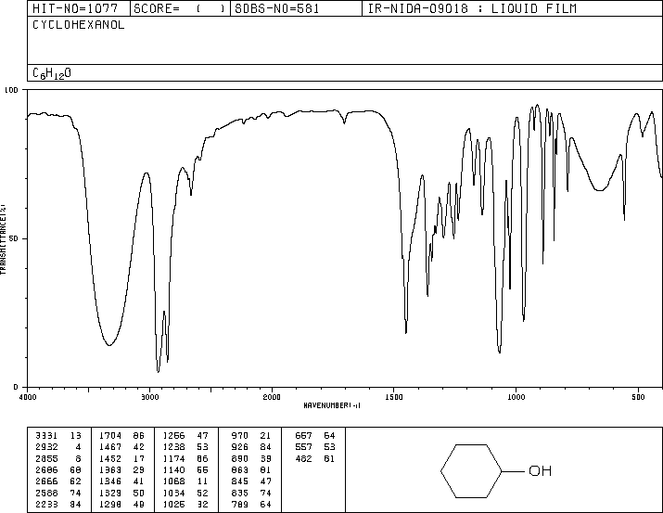

Literature Infrared Spectrum for cyclohexene
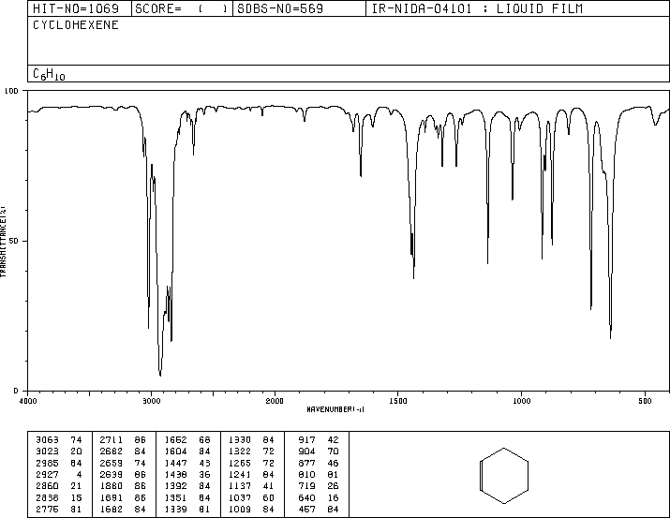

Chem350 Experiment 8 (Alternate) Report Date:___________

Student Name:___________________ ID Number:___________

Experiment 8 (Alternate) Prelab Questions

1. The preparing of methylpentenes from 4-methyl-2-pentanol is an example of a widely used method of converting an alcohol functional group into an _______________ functional group?
a. alkene
b. alkane
c. non-reactive.
d. reactive.

2. The purpose of adding sulfuric acid to the reaction vessel containing 4-methyl-2-pentanol is:
a. to neutralize any contaminating base.
b. to act as a catalyst in the reaction.
c. to slow the reaction rate and thereby increase the yield.

3. How do you separate the aqueous and the methylpentenes organic layer?
a. distillation.
b. reflux.
c. using a separatory funnel.
d. extraction.

4. The purpose of adding saturated sodium chloride (brine) to the aqueous layer in Step 8 of the procedure is to:
a. to make a salt of the organic acid.
b. to make the product less soluble in the water and to 'salt out' the water from the organic layer.
c. to preserve the product.
d. to add water to the organic layer.

5. Which of the following ways would characterize your final product and thereby help prove that you have converted 4-methyl-2-pentanol to methylpentenes:
a. infrared spectroscopy.
b. nuclear magnetic resonance spectroscopy.
c. refractive index.
d. density.
e. Final product is a mixture of isomers. Must further purify or analyze by chromatography.
f. only a and b are correct.

6. What is the first step called in the mechanism for an acid catalyzed dehydration?
a. protonation.
b. elimination.
c. carbocation intermediate formation.
d. substitution.

7. Alexander Zaitzev's rule for elimination reactions states:
a. "in the addition of HX to an alkene, the more highly substituted carbocation is formed as the intermediate rather than the less highly substitued one".
b. "Base-induced elimination reactions generally give the more highly substituted (more stable) alkene product".
c. "The structure of a transition state resembles the structure of the nearest stable species. Exergonic reaction steps resemble reactants and Endergonic reaction steps resemble products".

Experiment 8 Lab Safety

8. Which reagent(s) used in this experiment must be specially handled, and why?
a. saturated sodium chloride, as it is highly corrosive.
b. 4-methyl-2-pentanol, as it is the starting reagent.
c. hot sulfuric acid, as it is highly corrosive.
Chem350 Experiment 8 (Alternate) Report Date:___________

Student Name:___________________ ID Number:___________

Title:

Objective(s):

Reaction equation:

Introduction:

Procedure:
(Ref: )
Changes/Modification:

Procedure for the acid-catalyzed dehydration of 4-methyl-2-pentanol to form methylpentenes.
Procedural Step | Observations
Record amount of pure 4-methyl-2-pentanol used.

Setup

Reaction

Reaction Work-up

Final Distillation Procedure
1.
2.
3.
4.
5.
6.
Volume of Forerun
Boiling point range of forerun

Boiling point of product

Table 1. Table of Reagents for Optional Experiment 8
Reagent | Formula | Mwt.  (g/mol) | Mp  (°C) | Bp  (°C) | Hazardous Properties
4-methyl-2-pentanol | C₆H₁₄O | 102.18 |  | 132
sulfuric acid | H₂SO₄
sodium hydroxide (10%) | NaOH
sodium chloride | NaCl
calcium chloride | CaCl₂
acetone (wash) | CH₃COCH₃ |  |  | 56.5 | Flammable liquid, irritant
1-pentene, 2-methyl | C₆H₁₂ | 84.16 |  | 62 | Flammable liquid, irritant
1-pentene, 4-methyl | C₆H₁₂ | 84.16 |  | 53-54 | Flammable liquid, irritant
2-pentene, 2-methyl | C₆H₁₂ | 84.16 |  | 67 | Flammable liquid, irritant
2-pentene, 3-methyl |  |  |  | 69 | Flammable liquid, irritant
2-pentene, 4-methyl |  |  |  | 57-58 | Flammable liquid, irritant
Optional Experiment 8 Results:

Table 2. Table Summarizing Observations:*

Procedural Step | Comment or Observation
*This table may be repetitious, but really it is a place for you to bring forward some very important observations from your flowchart or procedure./observ. page that are very relevant to your results and calculations.

Table 3. Properties of the Acid-Catalyzed Dehydration Products, Methylpentenes

Table 3. shows a summary of the results of the experiment. The calculations for theoretical yield and percent yield should be shown below the table. Note: ___________ was the limiting reagent, since the only other reagent involved in the reaction, sulfuric acid, served as a catalyst.

 | Mass  (g) | Appearance of Liquid | Boiling Pt.  (°C)  (/Pressure) | Theoretical Yield  (g) | % Yield
Methylpentenes

Boiling Point Pressure Correction:

Theoretical Yield Calculation:

% Yield Calculation:

Table 4. Tabulation of Characteristic Infrared Absorptions for 4-methyl-2-pentanol and methylpentenes.

Table 4 contains the (hypothetical) results of the Infrared Spectral Analyses for 4-methyl-2-pentanol and methylpentenes.

See also attached labelled spectra for peak numbering and identification.
4-methyl-2-pentanol | Peak# | Wavenumber (cm-1) | Peak  Shape  (sharp, broad) | Peak Intensity  (strong, medium or ,weak) | Functional Group  Indicated

methylpentenes | Peak# | Wavenumber (cm-1) | Peak  Shape  (sharp, broad) | Peak Intensity  (strong, medium or ,weak) | Functional Group  Indicated

Tabulation of GC methylpentenes results (http://www.remotelab.ca)

Table 1 Concentration (%v/v) of Isomers determined by Gas Chromatography

Component | %(v/v)
4-methyl-1-pentene
cis and trans-4-methyl-2-pentene
2-methyl-1-pentene
2-methyl-2-pentene
cis and trans-3-methyl-2-pentene

(attach online printed report to your lab report)
Discussion:
Comments on reasons for yield (high or low), purity (high or low), % isomers, sources of error, etc.:

Conclusion:
Structure of Products

Experiment 8 (Alternate/Optional) Post Lab Questions:

Answers to be submitted with report.

- What is the purpose of adding 10% sodium hydroxide solution to the distillate in step 6 of the procedure?

- Would infrared spectroscopy be useful in identifying the products of the reaction performed in this experiment? Briefly explain your answer.

Screen Capture of Online GC and GC spectrum of methylpentenes
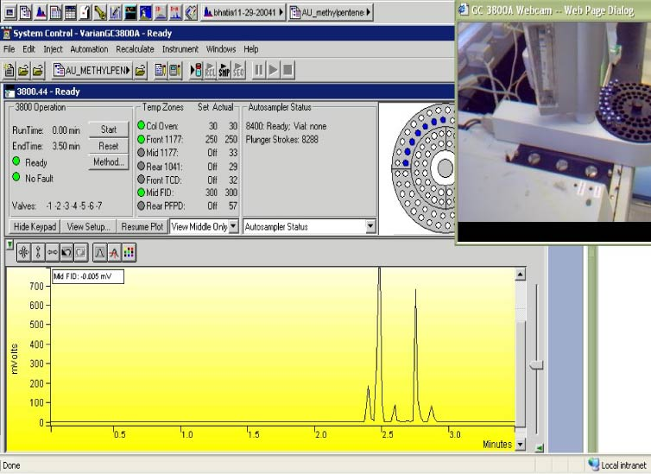

Experiment 8 (Alternate) Student Data for GC Analysis of methylpentenes product
Literature Infrared Spectrum for 4-methyl-2-pentanol
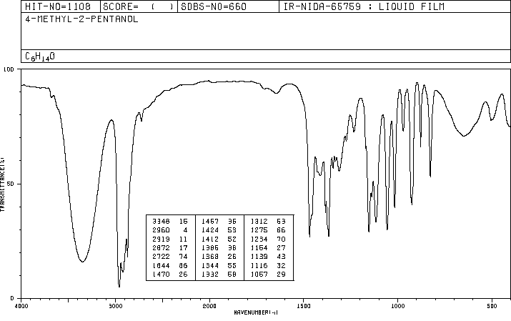

Literature Infrared Spectrum for 4-methyl-2-pentene (example of one of the methylpentene products)
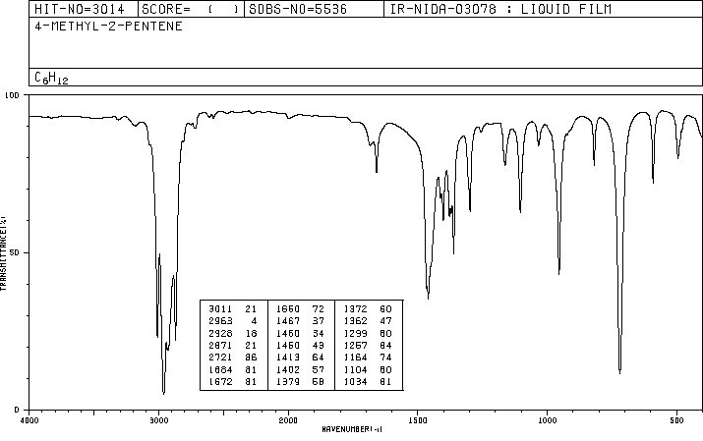

Chem350 Experiment 9 Report Date:___________

Student Name:___________________ ID #:___________

Experiment 9 Prelab Questions

1. What is the purpose of dissolving the acetanilide in glacial acetic acid prior to beginning the nitration reaction?
a. So that the acetanilide is 'in solution' when the sulfuric acid is added.
b. So that the acetanilide is 'in solution' when the nitrating mixture is added.
c. To stabilize the acetanilide prior to the addition of sulfuric acid.
d. To prevent the acetanilide from reacting to quickly when the nitrating mixture is added.

2. What happens when you mix sulfuric acid with nitric acid?
a. The sulfuric acid is the weaker acid so nitric acid converts it to sulfate ion.
b. Nitronium ion is formed.
c. a slow endothermic reaction occurs.

3. What is the name of the electrophile used in this experiment?
a. sulfuric acid.
b. nitirc acid.
c. acetanilide.
d. nitronium ion.

4. What acts as the nucleophile in this experiment?
a. sulfuric acid.
b. nitirc acid.
c. acetanilide.
d. nitronium ion.

5. Why do you wash the product several times (Procedure Steps 8-10) with ice-cold water?
a. to rinse away all unreacted acetanilide.
b. to rinse away excess acid.
c. a and b are correct.

6. How is the product characterized in this experiment?
a. melting point.
b. melting point and infrared spectroscopy.
c. yield, melting point and infrared spectroscopy.
d. none of the above.

7. What major differences in absorption bands would you expect to see in the infrared spectra of acetanilide and p-nitroacetanilide?
a. amide carbonyl adsorption at 1680 cm⁻¹ for both and only a nitro ~1500 cm⁻¹ adsorption at for the starting reagent.
b. the absorption due to the introduced nitro group in the product (1600-1500 and 1400-1300 cm⁻¹).
c. the absorption due to the introduced amide group in the product (1600-1500 and 1400-1300 cm⁻¹).

Experiment 9 Lab Safety

8. Which reagent(s) used in this experiment must be specially handled, and why?
a. nitric acid, it is highly corrosive.
b. glacial acetic acid, it is highly corrosive.
c. sulfuric acid, it is highly corrosive.
d. all of the above.
Chem350 Experiment 9 Report Date:___________

Student Name:___________________ ID Number:___________

Title:

Objective(s):

Equation(s):

Introduction:

Procedure:
(Ref: )
Changes/Modification:

Proc. For the electrophilic aromatic substitution of acetanilide to form p-nitroacetanilide.

Procedural Step | Observations
Record amount of pure acetanilide used.

Table 1. Table of Reagents for Experiment 9
Reagent | Formula | Mwt.  (g/mol) | Mp  (°C) | Bp  (°C) | Hazardous Properties
acetanilide
acetone (wash)

SAMPLE EXPERIMENT 9 FLOW CHART

REAGENT PROCEDURE / STEP OBSERVATION

Dissolve acetanilide
Reagent
Equip.
Prep.

Reaction

Quench Reaction
Product
Recovery
(Rxn.
Workup)

Prod.
Charact.
_____ g acetanilide

___ mL
conc. acetic acid

___ mL
conc. H₂SO₄

Add very slowly

Nitrating
Mixture
___ mL
conc. HNO₃
___ mL
conc. H₂SO₄
Add
very slowly

Nitration Reaction

100 mL water
+ 25 g ice
Precipitate Product

Collect Crude by Vacuum Filtration

Repeated washings

Recrystallization

mp
infrared spec.
______________

Experiment 9 Results:

Table 2. Table Summarizing Observations:*

Procedural Step | Comment or Observation
*This table may be repetitious, but really it is a place for you to bring forward some very important observations from your flowchart or procedure./observ. page that are very relevant to your results and calculations.

Table 3. Table of p-nitroacetanilide, Nitration Product.

Table 3 presents the summary of the results of the experiment. The calculations for limiting reagent, theoretical yield and percent yield are shown below the table. Note: _________________ was found to be the limiting reagent.

Name of product | Mass  (g) | Appearance of Crystals | Melting Pt.  (°C) | Theoretical Yield  (g) | % Yield

Limiting Reagent and Theoretical Yield Calculation:

% Yield Calculation:

Table 4. Tabulation of Characteristic Infrared Absorptions for acetanilide and p-nitroacetanilide.

Table 4 contains the results of the Infrared Spectral Analyses for acetanilide and p-nitroacetanilide. See also attached labelled spectra for peak numbering and identification.
Acetanilide | Peak# | Wavenumber  (cm-1) | Peak  Shape  (sharp, broad) | Peak Intensity  (strong, medium or ,weak) | Functional Group  Indicated

p-nitroacetanilide | Peak# | Wavenumber (cm-1) | Peak  Shape  (sharp, broad) | Peak Intensity  (strong, medium or ,weak) | Functional Group  Indicated

Discussion:
Comments on and give reasons for yield (high or low), purity, sources of error, and infrared spectrum results, etc.:

Conclusion:
Structure of Product

Experiment 9 Post Lab Questions:

Answers to be submitted with your lab report.

- During the nitration of acetanilide (Step 4 of the procedure), care is taken to keep the reaction mixture cool. What do you think might be the consequences of allowing the reaction mixture to become too warm?

- What organic compound (other than ethanol) would you reasonably expect to isolate from the ethanol/water mixture that was used to recrystallize your 4-nitroacetanilide?

Literature Infrared Spectrum of acetanilide (KBr disc)
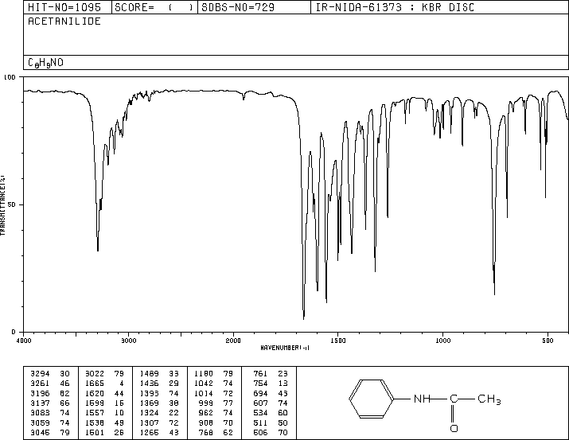

Literature Infrared Spectrum of p-nitroacetanilide (KBr disc)
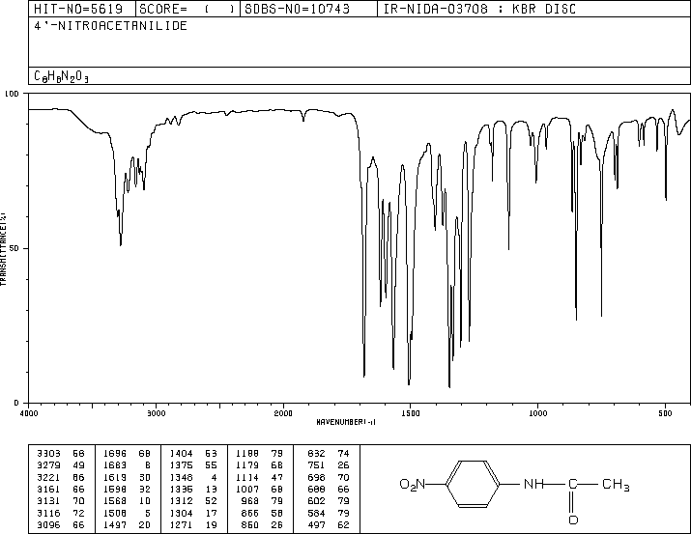

Compound  Name | Chemical  Formula | Solid (S) or Liquid (L) | Formula  Weight | MP or BP  (°C) | Density  (g/mL) | Refract.  Index | Hazardous  Properties*
acetanilide | CH₃CONHC₆H₅ | S | 135.17 | 113-115 |  |  | Toxic, irritant
acetanilide,4-methyl | CH₃CONHC₆H₄CH₃ | S | 149.19 | 149-151 |  |  | Irritant
acetanilide, p-nitro | CH₃CONHC₆H₄NO₂ | S | 180.16 | 216 |  |  | Irritant
acetanilide, o-nitro | CH₃CONHC₆H₄NO₂ | S | 180.16 | 94 |  |  | Irritant
acetanilide, m-nitro | CH₃CONHC₆H₄NO₂ | S | 180.16 | 154-156 |  |  | Irritant
acetic acid, glacial (17.4 M) | CH₃CO₂H | L | 60.05 | 118.1 | 1.049 |  | Corrosive, hygroscopic
acetic acid, p-ethoxyphenyl | C₂H₅OC₆H₄CH₂CO₂H | S | 180.2 | 87-90 |  |  | Irritant
acetic anhydride | (CH₃CO)₂O | L | 102.09 | 140 | 1.082 | 1.3900 | Corrosive, lachrymator
acetone | CH₃COCH₃ | L | 58.08 | 56.5 | 0.7899 | 1.3590 | Flammable, irritant
acetone, diethylamino | (C₂H₅)₂NCH₂COCH₃ | L | 129.2 | 64/16mm | 0.832 | 1.4250 | Irritant
acetophenone | C₆H₅COCH₃ | L | 120.15 | 202 | 1.030 | 1.5325 | Irritant
activated carbon |  | S |  |  |  |  | (see charcoal)
allyl alcohol (2-propen-1-ol) | CH₂=CHCH₂OH | L | 58.08 | 96-98 | 0.854 | 1.4120 | Highly Toxic, flammable
ammonia (14.8 M) | NH₃ | L | 17.03 |  | 0.90 |  | Corrosive, lachrymator
ammonium hydroxide (14.8 M) | NH₄OH | L | 35.05 |  | 0.90 |  | Corrosive, lachrymator
aniline | C₆H₅NH₂ | L | 93.13 | 184 | 1.022 | 1.5860 | Highly toxic, irritant
aniline, 4-bromo | BrC₆H₄NH₂ | S | 172.03 | 62-64 |  |  | Toxic, irritant
aniline, 4-chloro | ClC₆H₄NH₂ | S | 127.57 | 72.5 |  |  | Highly toxic, irritant
aniline, o-ethyl | CH₃CH₂C₆H₄NH₂ | L | 121.18 | 210 |  | 1.5590 | Toxic, irritant
aniline, 2-ethoxy | CH₃CH₂OC₆H₄NH₂ | L | 137.18 | 231-233 | 1.051 | 1.5550 | Irritant, light sensitive
aniline, 4-methyl | CH₃C₆H₄NH₂ | L | 107.16 | 196 | 0.989 | 1.5700 | Toxic, irritant
aniline, 3-nitro | NO₂C₆H₄NH₂ | S | 138.13 | 114 |  |  | Highly toxic, irritant
aspirin (see salicylic acid, acetate) | CH₃CO₂C₆H₄CO₂H | S | 180.16 | 138-140 |  |  | Irritant, toxic
benzaldehyde | C₆H₅CHO | L | 106.12 | 179.5 | 1.044 | 1.5450 | Hi.toxic, cancer susp.agent
benzaldehyde, 4-methyl | CH₃C₆H₄CHO | L | 120.15 | 204-205 | 1.019 | 1.5454 | Irritant (p-tolualdehyde)
benzaldehyde,4-methoxy | CH₃OC₆H₄CHO | L | 136.15 | 248 | 1.119 | 1.5730 | Irritant, (anisaldehyde)
benzaldehyde, 4-nitro | NO₂C₆H₄CHO | S | 151.12 | 106 |  |  | Irritant
benzene | C₆H₆ | L | 81.14 | 80.1 | 0.908 | 1.4990 | Flamm., cancer susp.agent
benzene, bromo | C₆H₅Br | L | 157.02 | 155-156 | 1.491 | 1.5590 | Irritant
benzene, chloro | C₆H₅Cl | L | 112.56 | 132 | 1.107 | 1.5240 | Flammable, irritant
benzoate, ethyl | C₆H₅CO₂C₂H₅ | L | 150.18 | 212.6 | 1.051 | 1.5050 | Irritant
benzoate, methyl | C₆H₅CO₂CH₃ | L | 136.15 | 198-199 | 1.094 | 1.5170 | Irritant
benzocaine,  4-aminobenzoic acid, ethyl ester, | H₂NC₆H₄CO₂C₂H₅ | S | 165.19 | 88-92 |  |  | Irritant
benzoic acid | C₆H₅CO₂H | S | 122.12 | 122.4 |  |  | Irritant
benzoic acid, 4-acetamido | CH₃CONHC₆H₄CO₂H | S | 179.18 | 256.5 |  |  | Irritant
benzoic acid, 4-amino | H₂NC₆H₄CO₂H | S | 137.14 | 188-189 | 1.374 |  | Irritant
benzoic acid, 3-chloro | ClC₆H₄CO₂H | S | 156.57 | 158 |  |  | Irritant
benzoic acid, 4-chloro | ClC₆H₄CO₂H | S | 156.57 | 243 |  |  | Irritant
benzoic acid, 3-hydroxy | HOC₆H₄CO₂H | S | 138.12 | 210-203 |  |  | Irritant
benzoic acid, 4-hydroxy | HOC₆H₄CO₂H | S | 138.12 | 215-217 |  |  | Irritant
benzoic acid, 2-methyl | CH₃C₆H₄CO₂H | S | 136.15 | 103-105 |  |  | See also o-toluic acid
benzoic acid, 4-methyl | CH₃C₆H₄CO₂H | S | 136.15 | 180-182 |  |  | See also p-toluic acid
benzoic acid, 4-nitro | O₂NC₆H₄CO₂H | S | 167.12 | 239-241 |  |  | Irritant
benzonitrile | C₆H₅CN | L | 103.12 | 191 | 1.010 | 1.5280 | Irritant
benzophenone | (C₆H₅)₂CO | S | 182.22 | 49-51 |  |  | Irritant
benzoyl chloride | C₆H₅COCl | L | 140.57 | 198 | 1.211 | 1.5530 | Corrosive, toxic
benzyl alcohol | C₆H₅CH₂OH | L | 108.14 | 205 | 1.045 | 1.5400 | Irritant, hygroscopic
benzyl amine | C₆H₅CH₂NH₂ | L | 107.16 | 184-185 | 0.981 | 1.5430 | Corrosive, lachrymator
benzyl chloride | C₆H₅CH₂Cl | L | 126.59 | 179 | 1.1002 |  | Hi.toxic, cancer susp.agent
biphenyl | C₆H₅C₆H₅ | S | 154.21 | 69-71 | 0.992 |  | Irritant
boric acid | H₃BO₃ | S | 61.83 |  | 1.435 |  | Irritant, hygroscopic
Brady’s Reagent | (NO₂)₂C₆H₃NHNH₂ | L | See hydrazine, 2,4-dinitrophenyl
bromine | Br₂ | L | 159.82 | 58.8 | 3.102 |  | Highly toxic, oxidizer
butanal | CH₃CH₂CH₂CHO | L | 72.11 | 75 |  |  | Flammable, corrosive
1,3-butadiene, E,E-1,4-diphenyl | C₆H₅C₄H₄C₆H₅ | S | 206.29 | 153 |  |  | Irritant
butane, 1-bromo | CH₃CH₂CH₂CH₂Br | L | 137.03 | 101.3 | 1.276 | 1.4390 | Flammable, irritant
butane, 2-bromo | CH₃CH₂CHBrCH₃ | L | 137.03 | 91.3 | 1.255 | 1.4369 | Flammable, irritant
Compound  Name | Chemical  Formula | Solid (S) or Liquid (L) | Formula  Weight | MP or BP  (°C) | Density  (g/mL) | Refract.  Index | Hazardous  Properties*
butane, 1-chloro | CH₃CH₂CH₂CH₂Cl | L | 92.57 | 78.4 | 0.886 | 1.4024 | Flammable liquid
butane, 2-chloro | CH₃CH₂CHClCH₃ | L | 92.57 | 68.2 | 0.873 | 1.3960 | Flammable liquid
1-butanol | CH₃CH₂CH₂CH₂OH | L | 74.12 | 117-118 | 0.810 | 1.3990 | Flammable, irritant
2-butanol | CH₃CH₂CHOHCH₃ | L | 74.12 | 99.5-100 | 0.807 | 1.3970 | Flammable, irritant
2-butanone | CH₃CH₂COCH₃ | L | 72.11 | 80 | 0.805 | 1.3790 | Flammable, irritant
2-butanone, 3-hydroxy-3-methyl | (CH₃)₂C(OH)COCH₃ | L | 102.13 | 140-141 | 0.971 | 1.4150 | Irritant
1-butene, 3-chloro- | CH₃CH(Cl)CH=CH₂ | L | 90.55 | 62-65 | 0.900 | 1.4155 | Flammable, lachrymator
3-buten-2-ol | CH₂=CHCH(OH)CH₃ | L | 72.11 | 96-97 | 0.832 | 1.4150 | Flammable, irritant
n-butyl butyrate | C₃H₇CO₂C₄H₉ | L | 144.21 | 164-165 | 0.871 | 1.4060 | Irritant
3-butyn-2-ol, 2-methyl | CH≡CC(CH₃)₂OH | L | 84.12 | 104 | 0.868 | 1.4200 | Flammable, toxic
calcium carbonate | CaCO₃ | S | 100.99 |  | 2.930 |  | Irritant, hygroscopic
calcium chloride, anhydr. | CaCl₂ | S | 110.99 |  | 2.150 |  | Irritant, hygroscopic
camphor (1R, +) | C₁₀H₁₆O | S | 152.24 | 179-181 | 0.990 | 1.5462 | Flamm., irritant
carbon dioxide, solid | CO₂ | S | 44.01 | -78.5(subl.) |  |  | Frost bite burns
carbon tetrachloride | CCl₄ | L | 153.82 | 76 | 1.594 |  | Susp. Cancer agent
charcoal (Norit) |  | S | Decolourizing agent, used in recrystallizations |  |  |  | Irritant
chloroform | CHCl₃ | L | 119.38 | 61.3 | 1.500 |  | Highly toxic
cinnamaldehyde, trans | C₆H₅CH=CHCHO | L | 132.16 | 246(decomp) | 1.048 | 1.6220 | Irritant
cinnamic acid, trans | C₆H₅CH=CHCO₂H | S | 148.16 | 135-136 |  |  | Irritant
crotonaldehyde | CH₃CH=CHCHO | L | 70.09 | 102.4 | 0.846 | 1.4365 | Highly toxic, flammable.
Cyclohexane | C₆H₁₂ | L | 84.16 | 80.7 | 0.779 | 1.4260 | Flammable, irritant
cyclohexane, bromo | C₆H₁₁Br | L | 163.06 | 166.2 | 1.324 | 1.4950 | Flammable, irritant
cyclohexane, methyl | C₆H₁₁CH₃ | L | 98.19 | 101 | 0.770 | 1.4220 | Flammable, irritant
cyclohexene | C₆H₁₀ | L | 82.15 | 83 | 0.811 | 1.4460 | Flammable, irritant
cyclohexanol | C₆H₁₁OH | L | 100.16 | 161.1 | 0.963 | 1.4650 | Irritant, hygroscopic
cyclohexanone | C₆H₁₀(=O) | L | 98.15 | 155.6 | 0.947 | 1.4500 | Corrosive, toxic
cyclohexanone, 4-methyl | CH₃C₆H₉(=O) | L | 112.17 | 170 | 0.914 | 1.4460 | Corrosive, toxic
cyclopentane | C₅H₁₀ | L | 70.14 | 49.5 | 0.751 | 1.4000 | Flammable, irritant
cyclopentane, bromo | C₅H₉Br | L | 149.04 | 137-138 | 1.390 | 1.4881 | Flammable
cyclopentanone | C₅H₈(=O) | L | 84.12 | 130.6 | 0.951 | 1.4370 | Flammable, irritant
dichloromethane | CH₂Cl₂ | L | 84.93 | 40.1 | 1.325 | 1.4240 | Toxic, irritant
diethyl ether (see ethyl ether) | C₂H₅OC₂H₅ | L | 74.12 | 34.6 | 0.708 | 1.3530 | Flammable, toxic
1,4-dioxane | C₄H₈O₂ | L | 88.11 | 100-102 | 1.034 | 1.4220 | Flamm., cancer susp.agent
diphenylmethanol | (C₆H₅)₂CH(OH) | S | 184.24 | 65-67 |  |  | Irritant
ethyl acetate | CH₃CO₂C₂H₅ | L | 88.11 | 76-77 | 0.902 | 1.3720 | Flammable, irritant
ethyl alcohol, anhydrous | CH₃CH₂OH | L | 46.07 | 78.5 | 0.785 | 1.3600 | Flammable, poison
ethyl ether, absolute | CH₃CH₂OCH₂CH₃ | L | 74.12 | 34.6 | 0.708 | 1.3530 | Flammable, irritant
fluorene | C₁₃H₁₀ | S | 166.22 | 114-116 |  |  | Irritant
formaldehyde (sol’n) | HCHO | L | 30.03 | 96 | 1.083 | 1.3765 | suspect. Cancer agent
formamide, N,N-dimethyl | HCON(CH₃)₂ | L | 73.10 | 149-156 | 0.9487 | 1.4310 | suspect. Cancer agent
furfuryl amine | (C₄H₃O)CH₂NH₂ | L | 97.12 | 145-146 | 1.099 | 1.4900 | Irritant
gold | Au | S | 196.97 | 1064 | 19.28 |  | Expensive/valuable
n-hexane | CH₃(CH₂)₄CH₃ | L | 86.18 | 69 | 0.659 | 1.3750 | Flammable, irritant
hydrazine, 2,4-dinitrophenyl | (NO₂)₂C₆H₃NHNH₂ | 70% soln | 198.14 |  |  |  | Flammable, irritant
hexanes | C₆H₁₄ | L | 86.18 | 68-70 | 0.672 | 1.3790 | Flammable, irritant
hydrochloric acid, conc. 12 M | HCl | L | 36.46 |  | 1.20 |  | Corrosive, highly toxic
iodine | I₂ | S | 253.81 | 133 | 4.930 |  | Corrosive, highly toxic
lichen |  | S |  |  |  |  | Allergin
ligroin (high bp petrol. Ether) | C₆-C₇ (light naphtha) | L |  | 60-80 | 0.656 | 1.3760 | Flammable, irritant
Lucas Reagent |  | Solution | of hydrochloric acid/zinc chloride (from zinc dust) |  |  |  | Toxic, irritant
magnesium (metal) | Mg | S | 24.31 | 651 | 1.75 |  | Flammable
magnesium oxide | MgO | S | 40.31 |  | 3.58 |  | Moist. Sens., irritant
magnesium sulfate, anhydrous | MgSO₄ | S | 120.37 |  | 2.660 |  | Hygroscopic
magnesium sulfate, 7-hydrate | MgSO₄.7H₂O | S | 246.48 |  | 1.670 |  | (psom salt)
manganese dioxide | MnO₂ | S | 86.94 | 535 (dec.) | 5.026 |  | Oxidizer, irritant
methanol, anhyd. | CH₃OH | L | 32.04 | 64.5 | 0.791 | 1.3290 | High. Toxic, flammable
methanol, diphenyl | (C₆H₅)₂CH(OH) | S | 184.24 | 69 |  |  | Irritant
methanol, triphenyl | (C₆H₅)₃C(OH) | S | 260.34 | 164.2 |  |  | Irritant
Compound  Name | Chemical  Formula | Solid (S) or Liquid (L) | Formula  Weight | MP or BP  (°C) | Density  (g/mL) | Refract.  Index | Hazardous  Properties*
methylene chloride | CH₂Cl₂ | L | 84.93 | 40.1 | 1.325 | 1.4230 | See dichlormethane
mineral spirits (light kerosene) | C₁₂-C₁₄ | L |  | 179-210 | 0.752 | 1.4240 | Flammable, irritant
naphthalene | C₁₀H₈ | S | 128.17 | 80.5 |  |  | Flamm., susp.cancer agent
nitric acid (conc. 15.4 M) | HNO₃ | L | 63.01 |  | 1.400 |  | Corrosive, oxidizer
2-octanone | CH₃(CH₂)₅COCH₃ | L | 128.22 | 173 | 0.819 | 1.4150 | Irritant
pentane | C₅H₁₂ | L | 72.15 | 36.1 | 0.626 | 1.3580 | Flammable, irritant
2-pentanol, 4-methyl | C₆H₁₄O | L | 102.18 | 132 | 0.802 | 1.4110 | Irritant
3-pentanol | C₂H₅CH(OH)C₂H₅ | L | 88.15 | 115/749mm | 0.815 | 1.4100 | Flammable, irritant
3-penten-2-one, 4-methyl | (CH₃)₂C=CHCOCH₃ | L | 98.15 | 129 | 0.858 | 1.4450 | Flammable, lachrymator
1-pentene, 2-methyl | C₆H₁₂ | L | 84.16 | 62 | 0.682 | 1.3920 | Flammable, irritant
1-pentene, 4-methyl | C₆H₁₂ | L | 84.16 | 53-54 | 0.665 | 1.3820 | Flammable, irritant
2-pentene, 2-methyl | C₆H₁₂ | L | 84.16 | 67 | 0.690 | 1.400 | Flammable, irritant
2-pentene, 3-methyl | C₆H₁₂ | L | 84.16 | 69 | 0.698 | 1.4040 | Flammable, irritant
2-pentene, 4-methyl | C₆H₁₂ | L | 84.16 | 57-58 | 0.671 | 1.3880 | Flammable, irritant
petroleum ether, (Skelly B) | Mixt. of C₅-C₆ | L |  | 35-60 | 0.640 |  | Flammable, toxic
petroleum ether, hi bp (ligroin) | Mixt. of C₆-C₇ | L |  | 60-80 | 0.656 | 1.3760 | Flammable, toxic
phenethyl alcohol | C₆H₅CH₂CH₂OH | L | 122.17 | 221/750mm | 1.023 | 1.5320 | Toxic, irritant
phenol | C₆H₅OH | S | 94.11 | 40-42 | 1.071 |  | Highly toxic, corrosive
phenol, 2,4-dimethyl | (CH₃)₂C₆H₃OH | S | 122.17 | 22-23 | 1.011 | 1.5380 | Corrosive, toxic
phenol, 2,5-dimethyl | (CH₃)₂C₆H₃OH | S | 122.17 | 75-77 | 0.971 |  | Corrosive, toxic
phenylacetylene | C₆H₅C≡CH | L | 102.14 | 142-144 | 0.930 | 1.5490 | Flamm., cancer susp.agent
phenylmagnesium bromide | C₆H₅MgBr | L | 181.33 |  | 1.134 |  | Flammable, moist.sensit.
phosphoric acid (85%, 14.7 M) | H₃PO₄ | L | 98.00 |  | 1.685 |  | Corrosive
potassium chromate | K₂CrO₄ | S | 194.20 | 968 | 2.732 |  | Canc.susp.agent, oxidizer
potassium dichromate | K₂Cr₂O₇ | S | 294.19 | 398 |  |  | Hi.toxic, canc.susp.agent
potassium hydroxide | KOH | S | 56.11 |  |  |  | Corrosive, toxic
potassium iodide | KI | S | 166.01 | 681 | 3.130 |  | Moist.sens., irritant
potassium permanganate | KMnO₄ | S | 158.04 | d<240 | 2.703 |  | Oxidizer, corrosive
propane, 2-chloro, 2-methyl | (CH₃)₃CCl | L | 92.57 | 50 | 0.851 | 1.3848 | Flammable
propane, 2-nitro | (CH₃)₂CHNO₂ | L | 89.09 | 120 | 0.992 | 1.3940 | Canc.susp.agent, flamm.
2-propanol, 2-methyl- | (CH₃)₃COH | L | 74.12 | 82.3 | 0.7887 |  | Flammable, irritant
propionate, ethyl | C₂H₅CO₂C₂H₅ | L | 102.13 | 99 | 0.891 | 1.3840 | Flammable, irritant
propionic acid | C₂H₅CO₂H | L | 74.08 | 141 | 0.993 | 1.3860 | Corrosive, toxic
rosaniline hydrochloride | C₂₀H₁₄(NH₂)₃Cl | Solution | 337.86 | 250 (dec) |  |  | Susp. cancer agent
salicylic acid | HOC₆H₄CO₂H | S | 138.12 | 158-160 |  |  | Toxic, irritant
salicylic acid, acetate ester | CH₃CO₂C₆H₄CO₂H | S | 180.16 | 138-140 |  |  | Irritant, toxic
Schiff’s Reagent |  | Solution | of roseaniline hydrochloride & sulfur dioxide |  |  |  | Toxic
silane, tetramethyl | Si(CH₃)₄ | L | 88.23 | 26-28 | 0.648 | 1.3580 | Flammable, hygroscopic
silica, sand | SiO₂ | S | 60.09 | NA |  |  | abrasive
silver nitrate | AgNO₃ | S | 169.88 | 212 | 4.352 |  | Highly toxic, oxidizer
sodium acetate | CH₃CO₂Na | S | 82.03 |  |  |  | hygroscopic
sodium bisulfite | NaHSO₃ | S |  |  | 1.480 |  | Severe irritant
sodium borohydride | NaBH₄ | S | 37.38 | 400 |  |  | Flam. solid, corrosive
sodium bicarbonate | NaHCO₃ | S | 84.01 |  | 2.159 |  | Moist. sensitive
sodium carbonate | Na₂CO₃ | S | 105.99 | 851 | 2.532 |  | Irritant, hygroscopic
sodium chloride | NaCl | S | 58.44 | 801 | 2.165 |  | Irritant, hygroscopic
sodium dichromate, dihydrate | Na₂Cr₂O₇.2H₂O | S | 298.00 |  | 2.350 |  | Hi.toxic, cancer susp.agent
sodium hydrogen carbonate | NaHCO₃ | S | 84.01 |  | 2.159 |  | See sodium bicarbonate
sodium hydroxide | NaOH | S | 40.00 |  |  |  | Corrosive, toxic
sodium iodide | NaI | S | 149.89 | 661 | 3.670 |  | Moist.sens., irritant
sodium metabisulfite | Na₂S₂O₅ | S | 190.10 |  | 1.480 |  | Moist.sens., toxic
sodium methoxide | NaOCH₃ | S | 54.02 |  |  |  | Flam. solid, corrosive
sodium sulfate | Na₂SO₄ | S | 142.04 | 884 | 2.680 |  | Irritant, hygroscopic
styrene | C₆H₅CH=CH₂ | L | 104.15 | 146 | 0.909 |  | Flammable
styrene, β-bromo | C₆H₅CH=CHBr | L | 183.05 | 112/20mm | 1.427 | 1.6070 | Irritant
sucrose | C₁₂H₂₂O₁₁ | S | 342.30 | 185-187 |  |  | Tooth Decay!
sulfur dioxide | SO₂ | Gas | 64.06 | -10 bp |  |  | Nonflamm, corrosive
Compound  Name | Chemical  Formula | Solid (S) or Liquid (L) | Formula  Weight | MP or BP  (°C) | Density  (g/mL) | Refract.  Index | Hazardous  Properties*
sulfuric acid (conc. 18 M) | H₂SO₄ | L | 98.08 |  | 1.840 |  | Corrosive, oxidizer
sulfurous acid | H₂SO₃ | L | 82.08 |  | 1.030 |  | Corrosive, toxic
L-tartaric acid | HO₂CC₂H₂(OH)₂CO₂H | S | 150.09 | 171-174 |  |  | Irritant
tetrahydrofuran | C₄H₈O | L | 72.11 | 65-67 | 0.889 | 1.4070 | Flammable, irritant
tetramethylsilane | Si(CH₃)₄ | L | 88.23 | 26-28 | 0.648 | 1.3580 | Flammable, hygroscopic
tin | Sn | S | 118.69 |  | 7.310 |  | Flammable solid, moist.sens.
Tollen’s Reagent |  | L | See ammonia + silver nitrate
toluene | C₆H₅CH₃ | L | 92.14 | 110.6 | 0.867 | 1.4960 | Flammable, toxic
toluene, 4-nitro | NO₂C₆H₄CH₃ | S | 137.14 | 52-54 | 1.392 |  | Hi.toxic, irritant
o- or 2-toluic acid | CH₃C₆H₄CO₂H | S | 136.15 | 103-105 |  |  | Probable irritant
p- or 4-toluic acid | CH₃C₆H₄CO₂H | S | 136.15 | 180-182 |  |  | Probable irritant
triethylphosphite | (C₂H₅O)₃P | L | 166.16 | 156 | 0.969 | 1.4130 | Moist. sens., irritant
triphenylmethanol | (C₆H₅)₃C(OH) | S | 260.34 | 160-163 |  |  | Probable irritant
urea | NH₂CONH₂ | S | 60.06 | 135 | 1.335 |  | Irritant
(-) usnic acid | C₁₈H₁₆O₇ | S | 344.32 | 198 |  |  | Toxic
(+) usnic acid | C₁₈H₁₆O₇ | S | 344.32 | 201-203 |  |  | Toxic
water | H₂O | L | 18.02 | 100 |  | 1.33 | Will burn skin when hot
water, ice | H₂O | S/L | 18.02 | 0 | 1.00 |  | Frostbite, hypothermia
xylenes | CH₃C₆H₄CH₃ | L | 106.17 | 137-144 | 0.860 | 1.4970 | Flammable, irritant
zinc dust | Zn | S | 65.37 | 419.5 |  |  | Flammable, moist.sens.
*Be sure to consult the chemical’s MSDS for more specific detail on hazardous properties.

CHEM350 Prelab Questions (Jun. 2016)

Exp.1 Prelab Question Answers:
Q1-b; Q2-c; Q3-a; Q4-b; Q5-c; Q6-d; Q7-a; Q8-a; Q9-c; Q10-d

Exp.2 Prelab Question Answers:
Q1-d; Q2-b; Q3-a; Q4-d; Q5-c; Q6-c; Q7-b; Q8-a; Q9-d; Q10-d; Q11-a

Exp.3 Prelab Question Answers:
Q1-b; Q2-c; Q3-a; Q4-d; Q5-c; Q6-b; Q7-e; Q8-c

Exp.4 Prelab Question Answers:
Q1-a; Q2-c; Q3-a; Q4-a; Q5-a; Q6-a

Exp.5 Prelab Question Answers:
Q1-c; Q2-b; Q3-a; Q4-b; Q5-b; Q6-c; Q7-c; Q8-d

Exp.6 Prelab Question Answers:
Q1-d; Q2-c; Q3-d; Q4-d; Q5-b; Q6-a; Q7-b

Exp.7 Prelab Question Answers:
Q1-e; Q2-a; Q3-b; Q4-b; Q5-a; Q6-c

Exp.8 Prelab Question Answers:
Q1-a; Q2-b; Q3-b; Q4-a; Q5-b; Q6-e; Q7-a; Q8-b; Q9-d

Exp.8 Alternate Prelab Question Answers:
Q1-a; Q2-b; Q3-c; Q4-b; Q5-e; Q6-a; Q7-b; Q8-c

Exp.9 Prelab Question Answers:
Q1-c; Q2-b; Q3-d; Q4-c; Q5-b; Q6-c; Q7-b; Q8-d

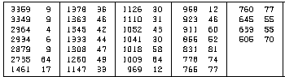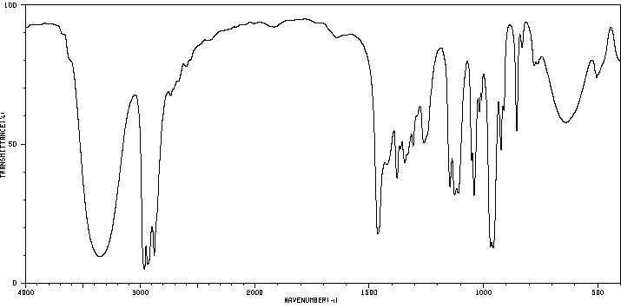 Unknown 350-6-1

Code:  Name:  Infrared Spectrum Region | Absorption  Band # | Wavenumber  (cm⁻¹) | Peak Shape  (sharp, broad) | Peak Intensity  (strong, medium or weak) | Functional Group  Indicated
Functional Group absent:
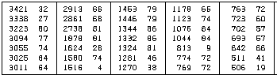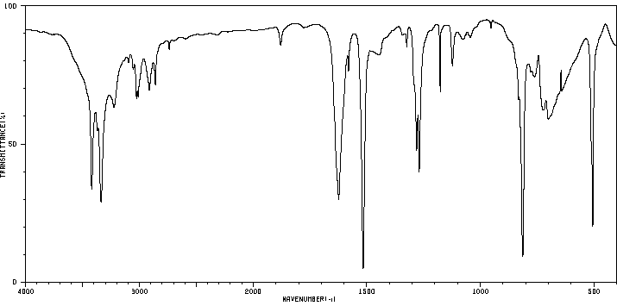Unknown 350-6-2

Code:  Name:  Infrared Spectrum Region | Absorption  Band # | Wavenumber  (cm⁻¹) | Peak Shape  (sharp, broad) | Peak Intensity  (strong, medium or weak) | Functional Group  Indicated
Functional Group absent:
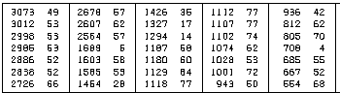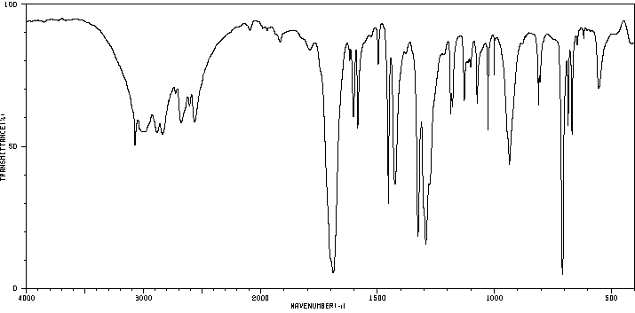 Unknown #350-6-3

Code:  Name:  Infrared Spectrum Region | Absorption  Band # | Wavenumber  (cm⁻¹) | Peak Shape  (sharp, broad) | Peak Intensity  (strong, medium or weak) | Functional Group  Indicated
Functional Group absent:
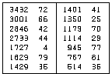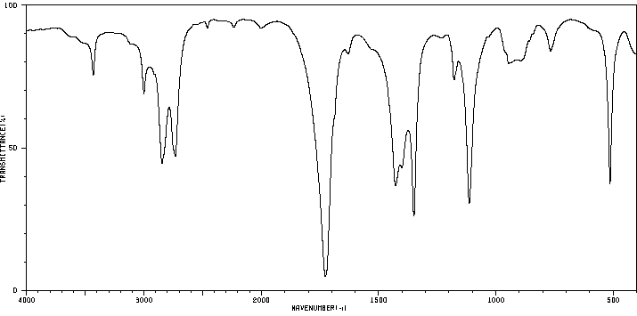Unknown #350-6-4

Code:  Name:  Infrared Spectrum Region | Absorption  Band # | Wavenumber  (cm⁻¹) | Peak Shape  (sharp, broad) | Peak Intensity  (strong, medium or weak) | Functional Group  Indicated
Functional Group absent:
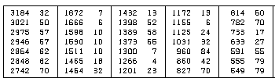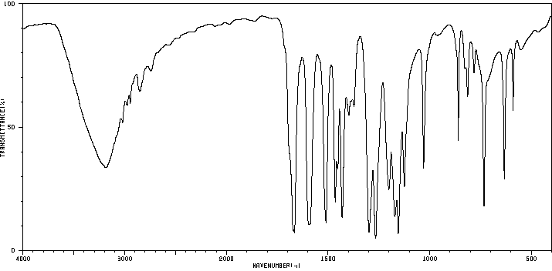Unknown #350-6-5

Code:  Name:  Infrared Spectrum Region | Absorption  Band # | Wavenumber  (cm⁻¹) | Peak  Shape  (sharp, broad) | Peak Intensity  (strong, medium or weak) | Functional Group  Indicated
Functional Group absent:
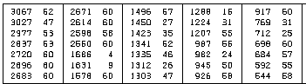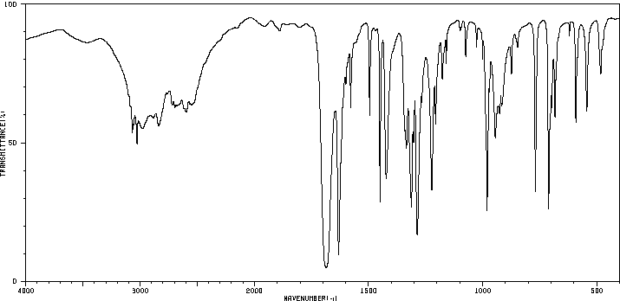Unknown #350-6-6
Code:  Name:  Infrared Spectrum Region | Absorption  Band # | Wavenumber  (cm⁻¹) | Peak  Shape  (sharp, broad) | Peak Intensity  (strong, medium or weak) | Functional Group  Indicated
Functional Group absent:
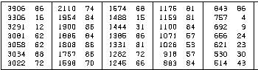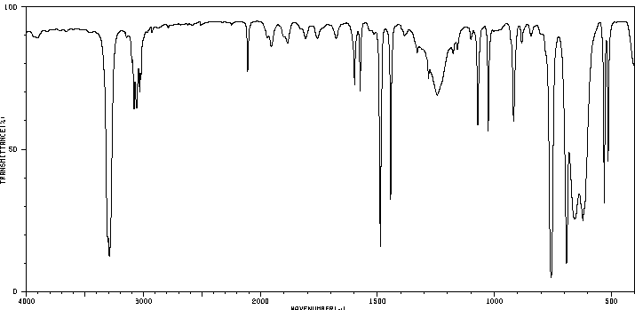Unknown #350-6-7

Code:  Name:  Infrared Spectrum Region | Absorption  Band # | Wavenumber  (cm⁻¹) | Peak  Shape  (sharp, broad) | Peak Intensity  (strong, medium or weak) | Functional Group  Indicated
Functional Group absent: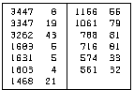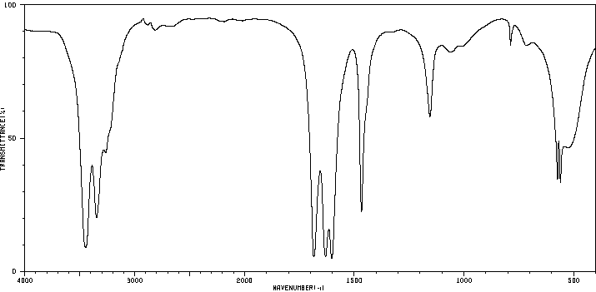Unknown #350-6-8

Code:  Name:  Infrared Spectrum Region | Absorption  Band # | Wavenumber  (cm⁻¹) | Peak  Shape  (sharp, broad) | Peak Intensity  (strong, medium or weak) | Functional Group  Indicated
Functional Group absent: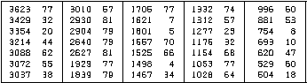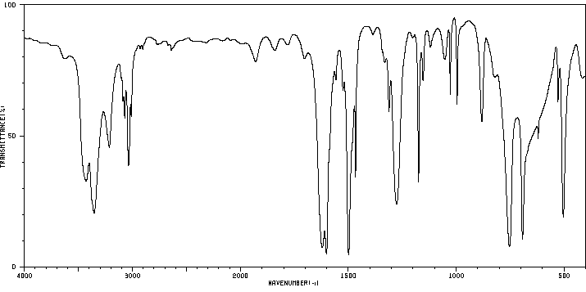Unknown #350-6-9

Code:  Name:  Infrared Spectrum Region | Absorption  Band # | Wavenumber  (cm⁻¹) | Peak  Shape  (sharp, broad) | Peak Intensity  (strong, medium or weak) | Functional Group  Indicated
Functional Group absent: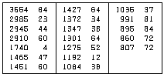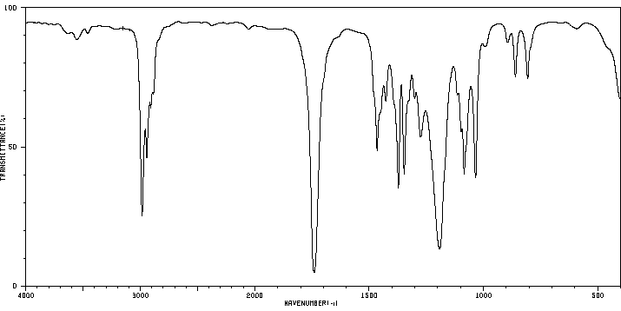Unknown #350-6-10

Code:  Name:  Infrared Spectrum Region | Absorption  Band # | Wavenumber  (cm⁻¹) | Peak  Shape  (sharp, broad) | Peak Intensity  (strong, medium or weak) | Functional Group  Indicated
Functional Group absent: 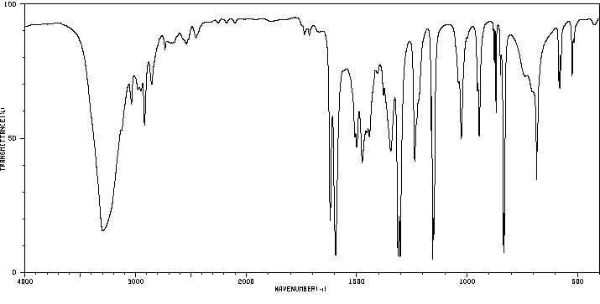Unknown #350-6-11

Code:  Name:  Infrared Spectrum Region | Absorption  Band # | Wavenumber  (cm⁻¹) | Peak  Shape  (sharp, broad) | Peak Intensity  (strong, medium or weak) | Functional Group  Indicated
Functional Group absent: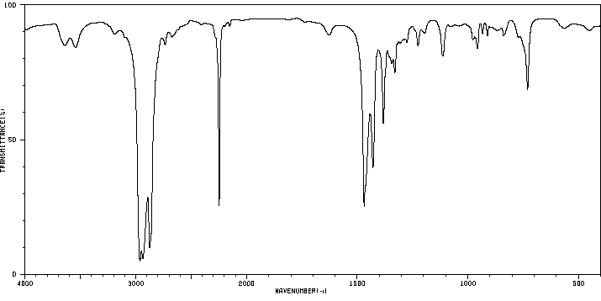Unknown #350-6-12

Code:  Name:  Infrared Spectrum Region | Absorption  Band # | Wavenumber  (cm⁻¹) | Peak  Shape  (sharp, broad) | Peak Intensity  (strong, medium or weak) | Functional Group  Indicated
Functional Group absent:
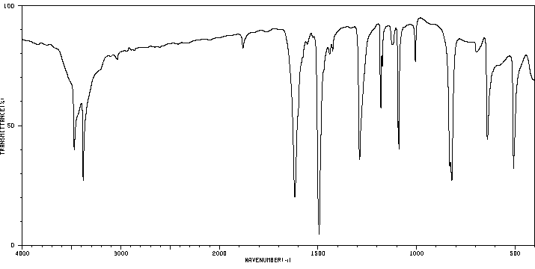Unknown #350-6-13
Code:  Name:  Infrared Spectrum Region | Absorption  Band # | Wavenumber  (cm⁻¹) | Peak  Shape  (sharp, broad) | Peak Intensity  (strong, medium or weak) | Functional Group  Indicated
Functional Group absent: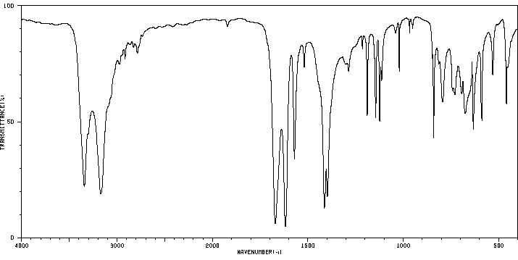Unknown #350-6-14

Code:  Name:  Infrared Spectrum Region | Absorption  Band # | Wavenumber  (cm⁻¹) | Peak Shape  (sharp, broad) | Peak Intensity  (strong, medium or weak) | Functional Group  Indicated
Functional Group absent: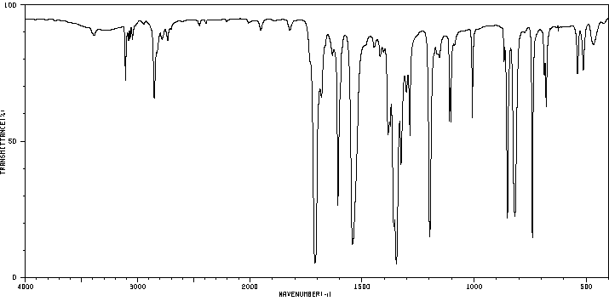Unknown #350-6-15

Code:  Name:  Infrared Spectrum Region | Absorption  Band # | Wavenumber  (cm⁻¹) | Peak Shape  (sharp, broad) | Peak Intensity  (strong, medium or weak) | Functional Group  Indicated
Functional Group absent: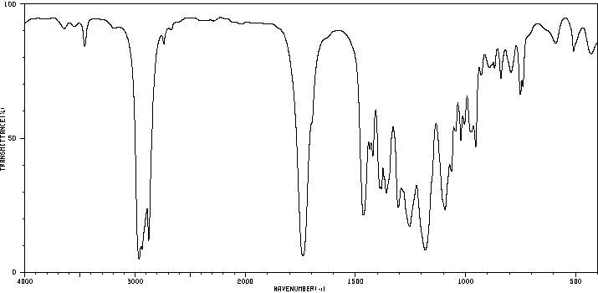Unknown #350-6-16

Code:  Name:  Infrared Spectrum Region | Absorption  Band # | Wavenumber  (cm⁻¹) | Peak Shape  (sharp, broad) | Peak Intensity  (strong, medium or weak) | Functional Group  Indicated
Functional Group absent: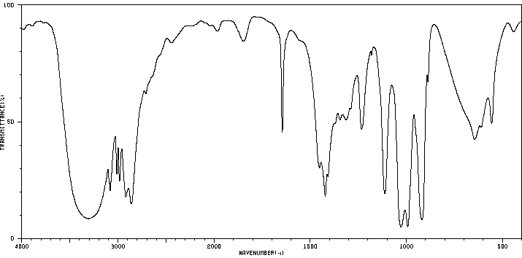Unknown #350-6-17

Code:  Name:  Infrared Spectrum Region | Absorption  Band # | Wavenumber  (cm⁻¹) | Peak Shape  (sharp, broad) | Peak Intensity  (strong, medium or weak) | Functional Group  Indicated
Functional Group absent: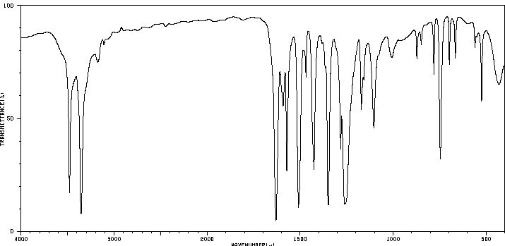Unknown #350-6-18

Code:  Name:  Infrared Spectrum Region | Absorption  Band # | Wavenumber  (cm⁻¹) | Peak Shape  (sharp, broad) | Peak Intensity  (strong, medium or weak) | Functional Group  Indicated
Functional Group absent:
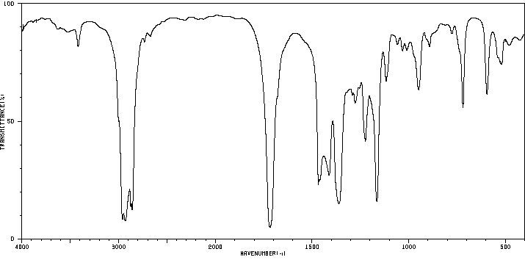Unknown #350-6-19

Code:  Name:  Infrared Spectrum Region | Absorption  Band # | Wavenumber  (cm⁻¹) | Peak Shape  (sharp, broad) | Peak Intensity  (strong, medium or weak) | Functional Group  Indicated
Functional Group absent: 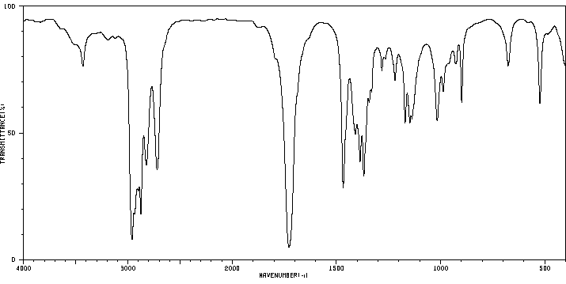Unknown #350-6-20

Code:  Name:  Infrared Spectrum Region | Absorption  Band # | Wavenumber  (cm⁻¹) | Peak Shape  (sharp, broad) | Peak Intensity  (strong, medium or weak) | Functional Group  Indicated
Functional Group absent:

