Graduate Student / Non-AU Researcher

Instructions

Description:
This document demonstrates how to:

- Complete and submit an application for Ethical Approval at Athabasca University if you are a graduate student and/or non-AU researcher.
- Complete and submit any requested revisions/clarifications following review of your application.
- Complete any required reporting throughout the life of your research project including: requests to modify/amend an approved project, requests to renew ethical approval, reporting adverse or unanticipated events, and mandatory final reporting.

Completing and submitting an application for ethical approval
- Complete the CORE (Course on Research Ethics) Online Tutorial (mandatory) and save your Certificate of Completion to your desktop. You will submit your certificate of completion with your ethics application.
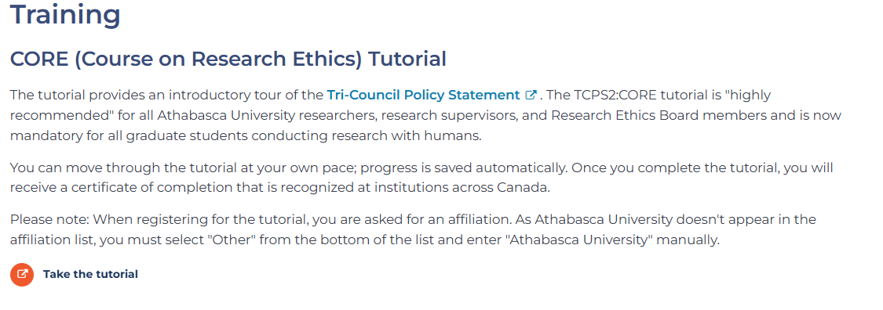
- Go to the Ethics website and download the appropriate application form and appropriate recruitment and consent template(s).
- Complete the appropriate application form and tailor/create all required attachments (e.g. References List, Recruitment/Invitation Document(s), Consent Document(s), Research Instruments/Tools, etc.).
- Save all documents.

Steps 5 – 6 are applicable only to graduate student applicants
Graduate Student Applicants:
- Email the completed application and attachments to your supervisor for review/approval.
- Make any necessary edits/revisions requested by your supervisor. Download and save the email approval from your Supervisor and submit this with your application.

Graduate Student & Non-AU Researchers

- Email your completed application form and accompanying attachments to the Research Ethics Officer at rebsec@athabascau.ca.
- The Research Ethics Officer will conduct an initial review of your submission and may suggest some revisions/clarifications prior to sending the application forward for review.
- If requested, make any revisions to your application and documentation and email the revised documentation to the Research Ethics Officer at rebsec@athabascau.ca.
- The Research Ethics Officer will forward your application and attachments for review (Delegated or Full Board). You will receive a decision via email.

If Revisions are Requested by the Research Ethics Board following review of your application
- Make any changes to your application form and documentation using “Track Changes” so that edits are readily visible.
- Draft a summary document responding to the feedback provided that outlines the changes made within your application form and documentation.
- Email your revised application form, summary document and all revised attachments to the Research Ethics Officer at rebsec@athabascau.ca.
- The Research Ethics Officer will forward your application and attachments for further review (Delegated or Full Board). You will receive a decision via email.

Following Ethical Approval
Ethics approval is granted for a period of 12 months. If your project is not concluded within 12 months (or if it is a multi-year project) you will need to request a Renewal of your ethical approval.

Tri-Agency and AU Policy requires that a final report be submitted at the conclusion of your research project to close out Research Ethics Board monitoring of the project.

If you need to modify or amend an approved project or report an unanticipated or adverse event, you will need to submit the appropriate report form for approval by the Research Ethics Board.

All reporting forms can be found on the Research Ethics Website

Once completed, email the reporting form to the Research Ethics Officer via email to rebsec@athabascau.ca

If you have any difficulties or questions, please contact the Research Ethics Officer at rebsec@athabascau.ca

