

Implementing and Operationalizing

Integrated Planning

Dr. Matthew Prineas

Provost and Vice-President Academic

April 2018

**MESSAGE FROM THE PROVOST**

Integrated Planning is a multi-year approach to institutional planning which emphasizes transparency, predictability, accountability, and effectiveness by linking long-range planning and annual budgeting. It is a process whereby planning at every level is driven by an institution’s strategic plan. Success in integrated planning can be defined as the allocation and reallocation of resources to drive institutional strategic directions forward.

This description assumes a rather straightforward, rational process of decision making; it involves careful preparation of future decision through planning, strategic alignment, a choice among alternatives, and implementation. Because integrated planning touches on all segments of an institution’s operations, it will likely take us a year to put into place all the components of a complete annual cycle.

Over the next several months, I will be working closely with the university community to lead the implementation of integrated planning into all our planning processes. With support from the Provost’s Office and the VPFA Division, and operationalized by Administrative Council, we will build an enhanced approach to planning that builds relationships, aligns our planning, and emphasizes our preparedness for transformation. Like information technology, integrated planning needs to be woven into all our future planning activities.

AU is not alone in this journey. Post-secondary institutions across Canada have implemented integrated planning to enhance their planning processes and to drive their strategic goals and priorities forward. Like many institutions across Alberta and Canada, we face many pressures including limited government funding, fluctuating enrolment, government policy that restricts tuition increases, increased competition, and increased demands from government and stakeholders for specific outcomes. We have limited resources, and must make hard choices about what is most important for the university as a whole. Through integrated planning, we will address these pressures.

As an institution, we need to direct and redirect our resources and efforts to align with our new strategic plan: [*Imagine: Transforming Lives, Transforming Communities*](http://imagine.athabascau.ca/)*.* In doing so, will manage our expectations, demonstrate our commitment to accountability and continuous improvement, and work jointly together toward dedicated, specific, and measurable goals and directions outlined in our new *Imagine Plan.* Integrated planning will also provide more transparency in how decision are made and increase our understanding of direct and indirect costs of our initiatives. Lastly, as a collective, we will increase our agility and strategic thinking through enhanced planning that will allow us to mobilize to seize opportunities and prepare for potential threats.

During our most recent resource planning process, we endeavored to move towards integrated planning by using the *Imagine: Transforming Lives, Transforming Communities* strategic plan to inform our resource planning for FY18-19. The process was challenging, as our *Imagine* plan was still in draft form through much of this period. With the approval of the plan in December 2017, our roadmap is clear. Over the next several months, we will work together to rollout integrated planning in its fullness. Our goal is to build a shared understanding of the *Imagine* *Plan* and financial performance; these are crucial for aligning our institutional resources with our strategic directions and emerging opportunities. The process will take one to two cycles before we see profound change. It may seem like a large hill to climb, but we will find our rhythm. I am confident that a clearer, more collaborative, and systematic resource planning framework will emerge.

***IMAGINE: TRANSFORMING LIVES, TRANSFORMING COMMUNITIES* IN ACTION**

Integrated planning requires a common understanding of our new strategic plan: [*Imagine: Transforming Lives, Transforming Communities*](http://imagine.athabascau.ca/)*.* The plan is comprised of the following elements:

◊ TITLE - *Imagine: Transforming Lives, Transforming Communities*

◊ SHORT FORM TITLE - Imagine Plan

◊ VISION - Transforming Lives, Transforming Communities

◊ CORE STORY - based on Open, Flexible, Everywhere

◊ I-CARE VALUES (AU Values) - Integrity, Community, Adaptability, Respect, Excellence

◊ AU COMMITMENTS - Investing in ourselves, shared responsibility, accountability, transforming, technology

◊ AU FOUNDATIONS - Reciprocity / Conciliation

◊ STRATEGIC THEMES - Moving Beyond Open / Moving Beyond Place / Moving Beyond the Now / Moving Beyond the Norm

◊ STRATEGIC DIRECTIONS - The strategic directions provide us with our compass directions and guideposts by which to make our collective institutional decisions (see Figure 1)

◊ SUCCESS ELEMENTS: Teaching and Learning Success; Research and Development Success; AU Success

◊ PRIORITY OUTCOMES - Core institutional strategic outcomes that demonstrate we have successfully realized our intended strategic direction(s) (See Figure 2)

In an integrated planning framework, it is the strategic directions that drive planning and resource allocation. They are our building blocks.

**FIGURE 1: Strategic Directions**

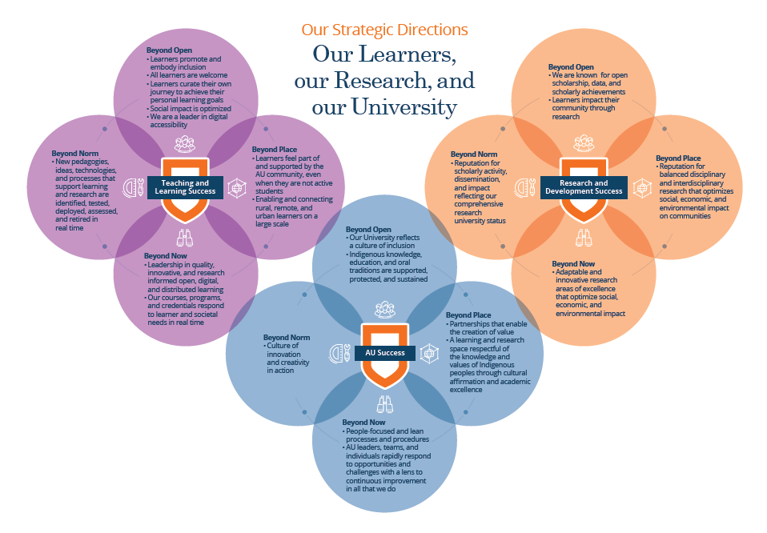

As part of integrated planning, budget holders will look to align their resource asks with a primary strategic direction. The strategic direction must be effectively linked to our priority outcomes.

**FIGURE 2: Priority Outcomes**

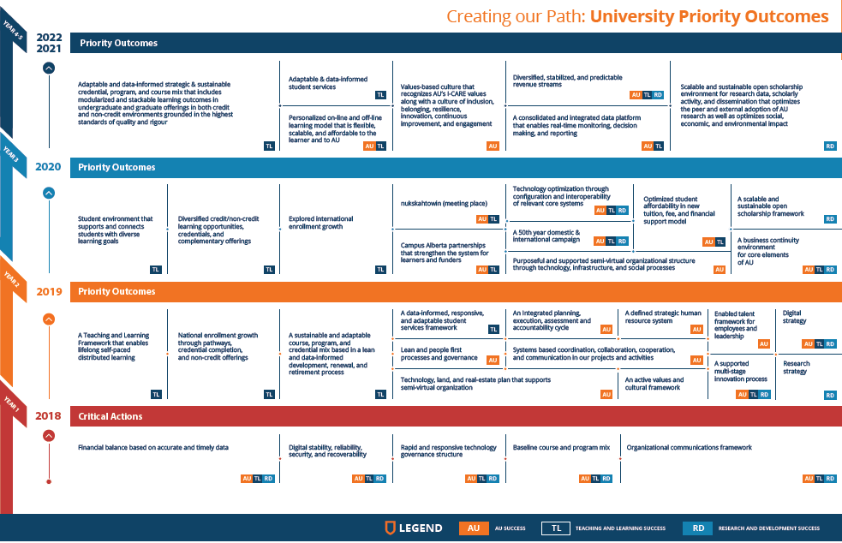

I will use the example of integrated planning. Integrated planning contributes to AU Success, Beyond Now (strategic theme), “AU leaders, teams, and individuals rapidly respond to opportunities and challenges with a lens to continuous improvement in all that we do" (strategic direction). It will result in the following 2022 outcome: "[a] consolidated and integrated data platform that enables real-time monitoring, decision making, and reporting." It will also contribute to our 2019 outcome of "[a]n integrated planning, execution, assessment and accountability cycle."

**INTEGRATED PLANNING FRAMEWORK IMPLEMENTATION**

The *Imagine* Plan is our masterplan; it is our roadmap to success. As the visual in *Appendix A* outlines, the *Imagine* Plan informs our foundational plans which outline detailed objectives and strategies that will drive our institutional strategic directions forward. The foundational plans, in essence, operationalize the *Imagine* *Plan* by becoming nested to the *Imagine* Plan and planning cycle. However, like a venn diagram, the process is a balanced interplay between the University plan and the foundational plans as ‘circles’ do not entirely overlap. That is, the *Imagine* Plan informs the high level unit decisions. In doing so, the foundational plans contribute to a “priorities portfolio” – a broad bucket of academic and operational priorities that will drive our *Imagine* strategic directions forward. The “priorities portfolio” impacts our rolling operational and financial plans as well as performance planning as it is linked to our capital and resources planning. Our annual integrated resource plan will outline the required resources to implement our priorities. These priorities will be responsive to the strategic, academic, and research goals of our institution. Everything we do will have a direct link to our vision, mission, and strategic directions. Everything we do will also be reflected in our institutional project portfolio.

As the visual illustrates, integrated planning also requires evaluation and assessment to determine whether we are on track or need to make adjustments and course corrections in our planning efforts, both at the strategic and operational levels. A Working Group is currently devising institutional Key Performance Indicators (KPIs) to measure our effectiveness. Input from Administrative Council is essential to determine which measures are most effective in measuring our progress and our success. In terms of the Comprehensive Institutional Plan (CIP) and Annual Report, they are in part a consolidation and a by-product of our overall planning approach and cycle.

**OPERATIONALIZING INTEGRATED PLANNING**

The concept of integrated planning requires leaders from faculty and administrative units to align their planning process and timelines to the master planning cycle. We need to plan, do, assess, and evaluate in a planning cycle that is synchronized. *Appendix B* outlines our new planning cycle.

As the visual demonstrates, integrated planning will be operationalized by members of Administrative Council. We will work together to refine the process and I anticipate that the 2018-2019 will be a learning year for all of us.

If you have any questions, please bring them to my attention at Administrative Council, or email me at [provost@athabascau.ca](mailto:provost@athabascau.ca).